**MSF TA2 Assignment**

1. **Demonstration of Android Application Framework component such as Activity and android manifest file etc. using Android Studio**

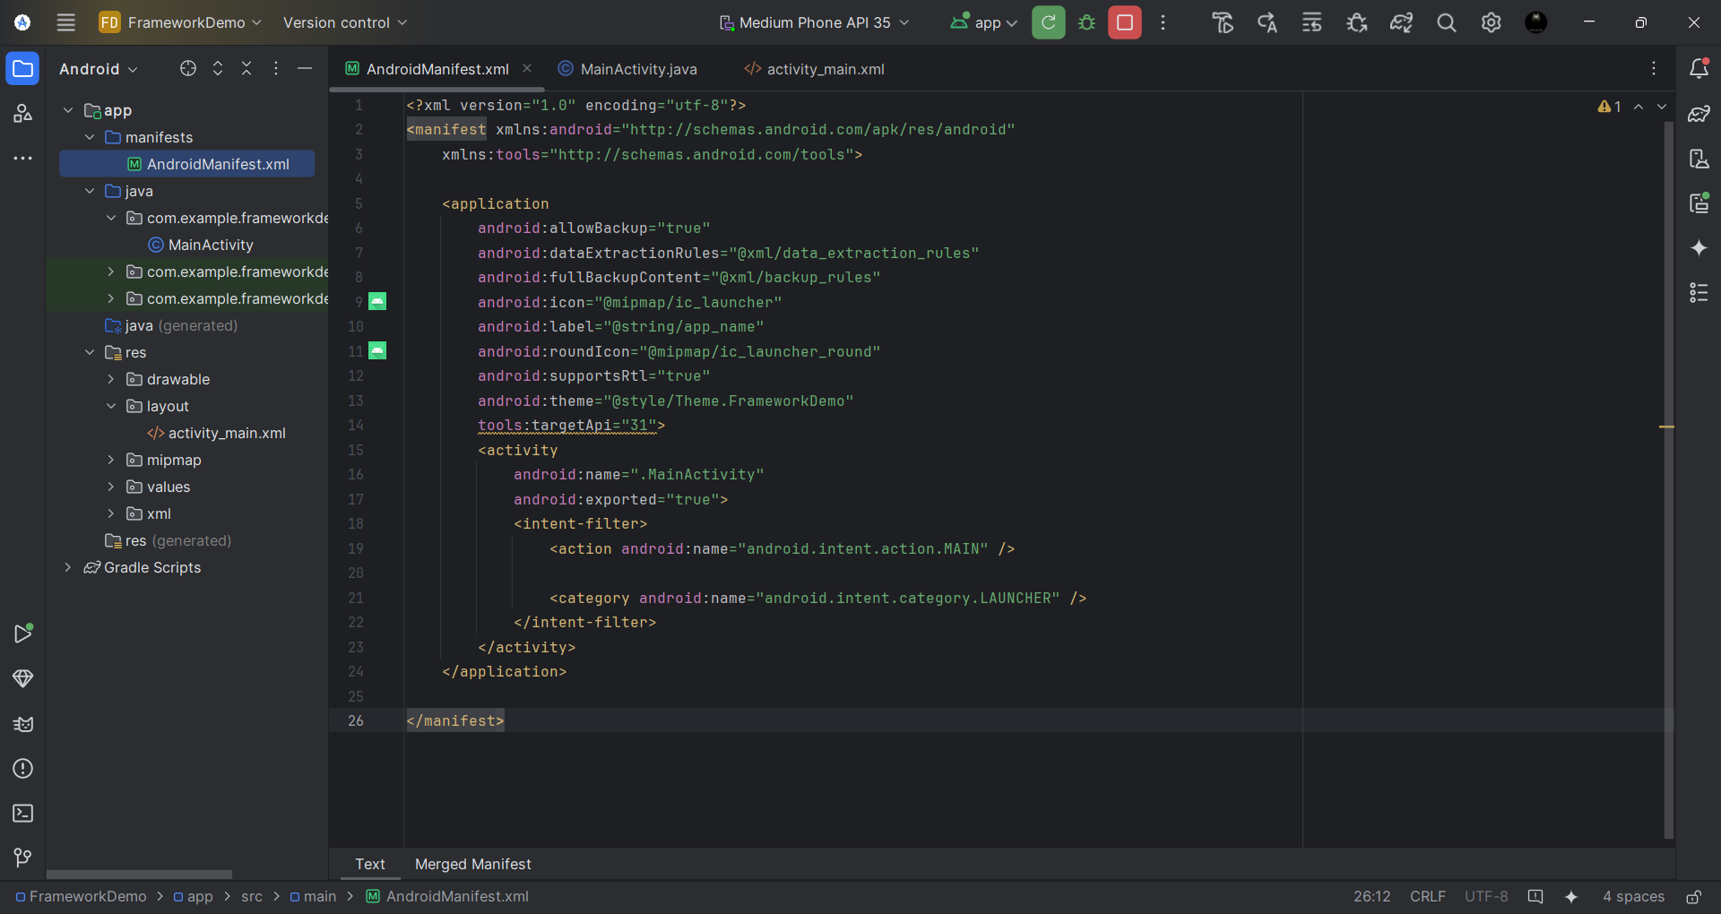

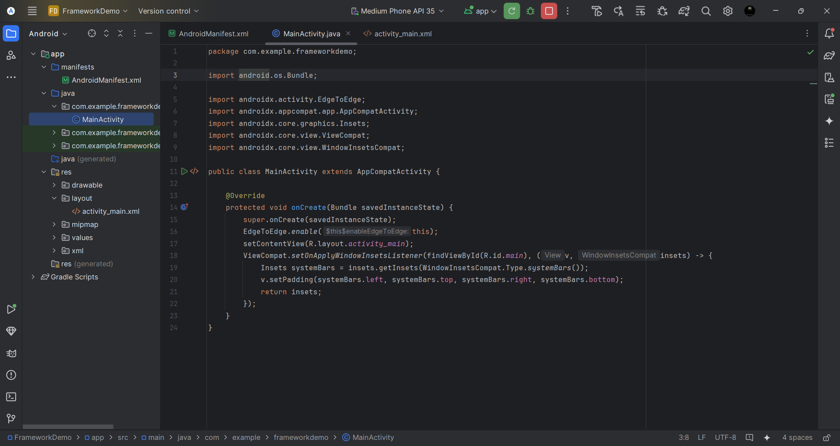

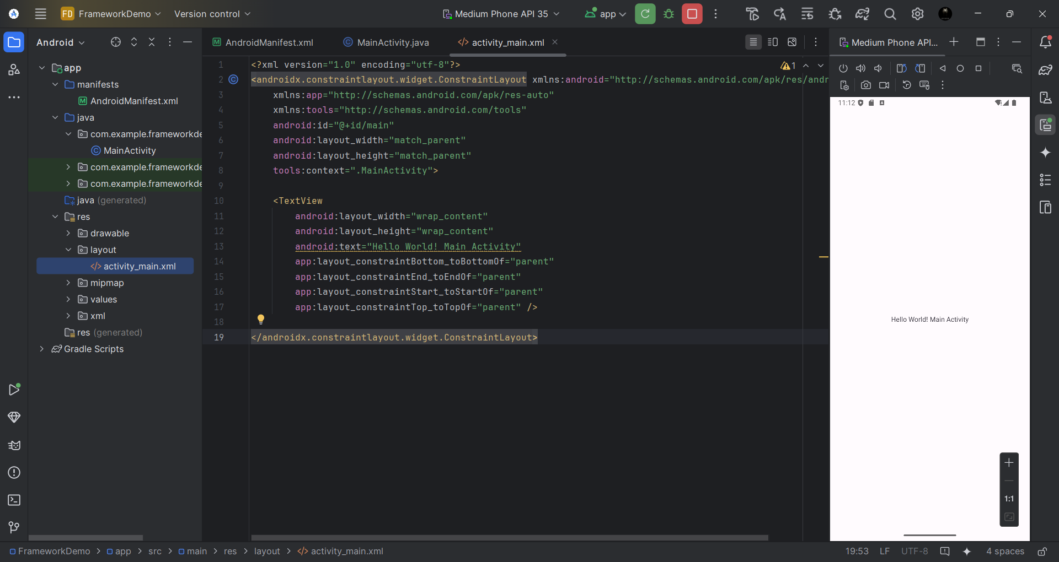

1. **Demonstration of Android Intent**

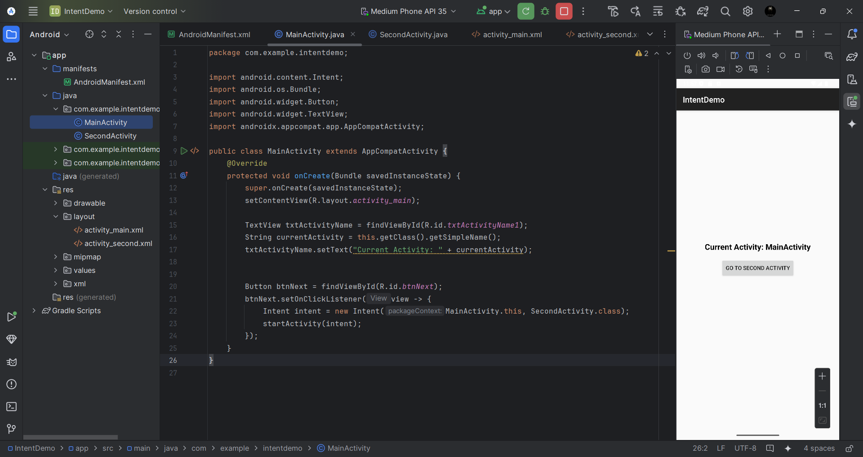

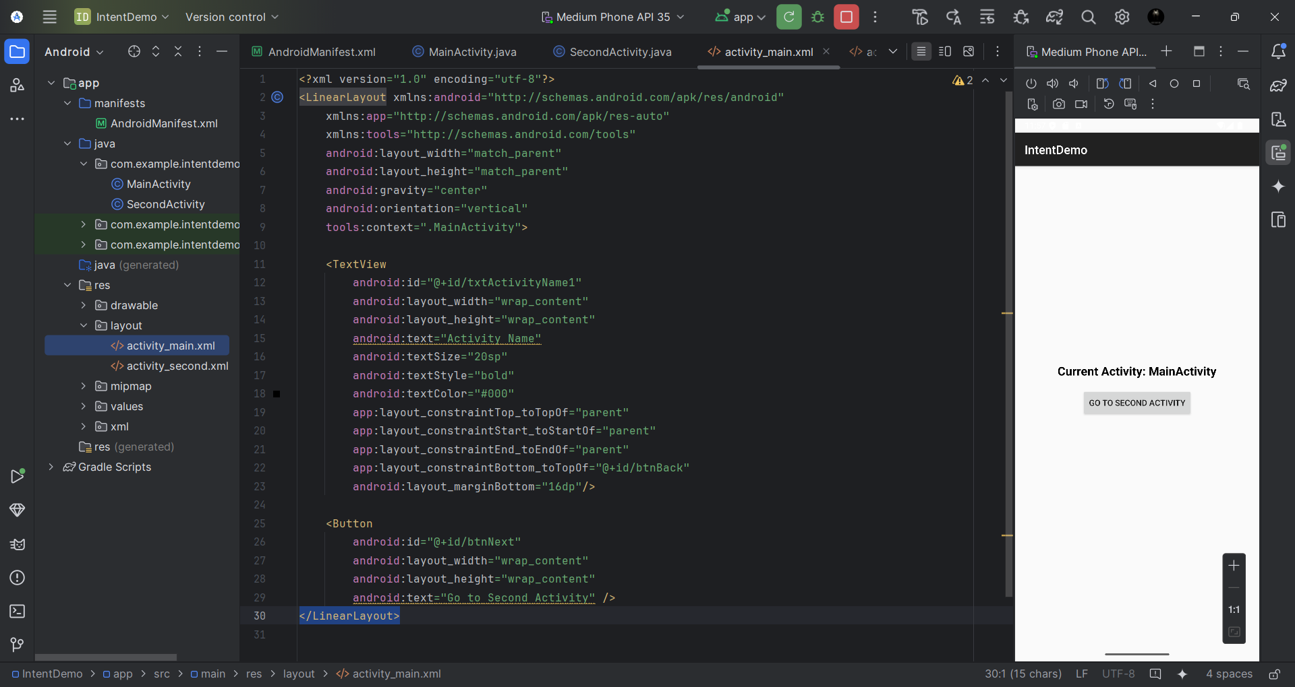

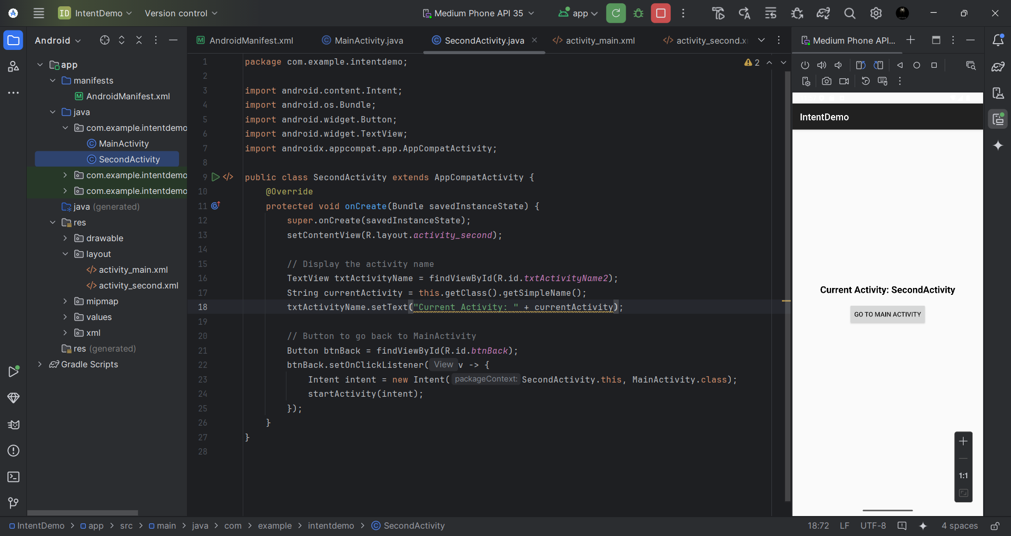

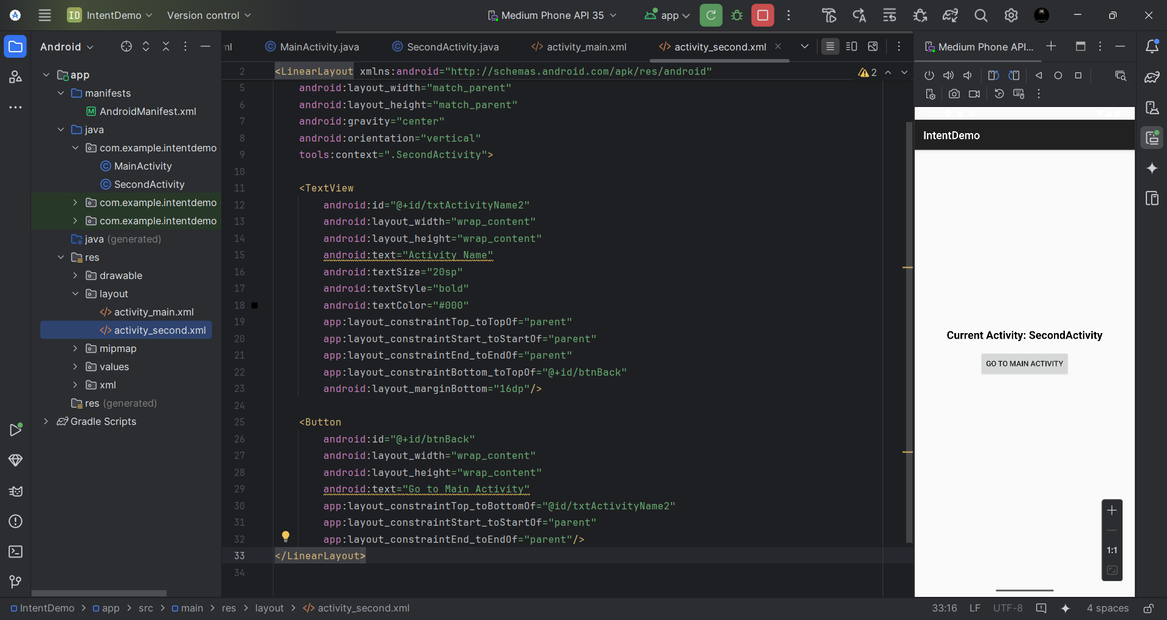

1. **Demonstration of Android Intent Filter**

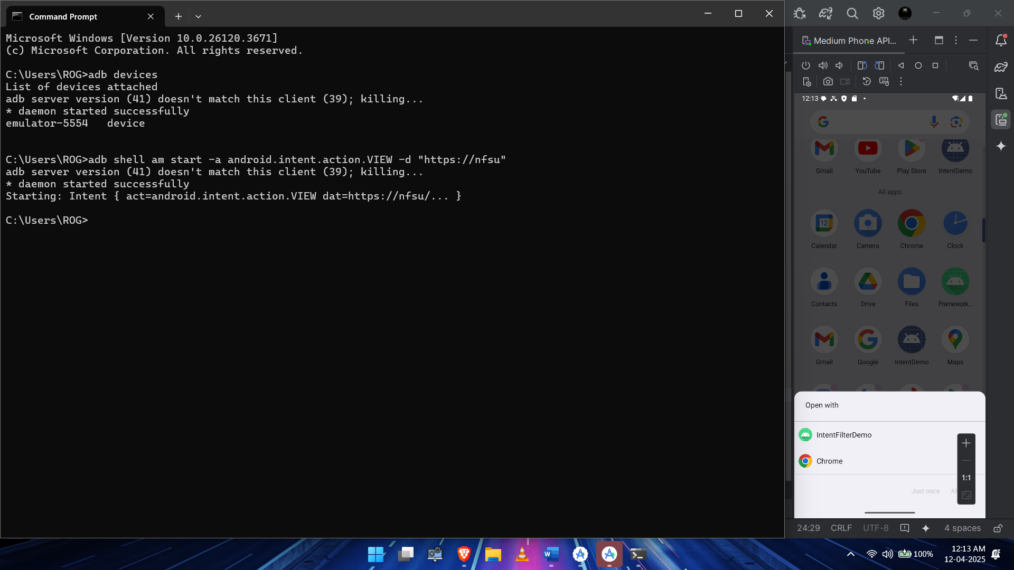

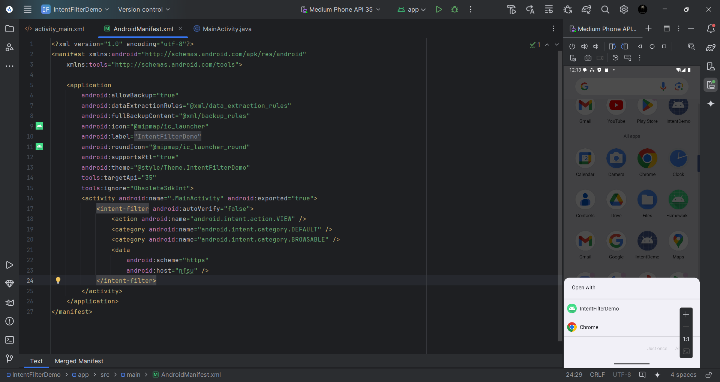

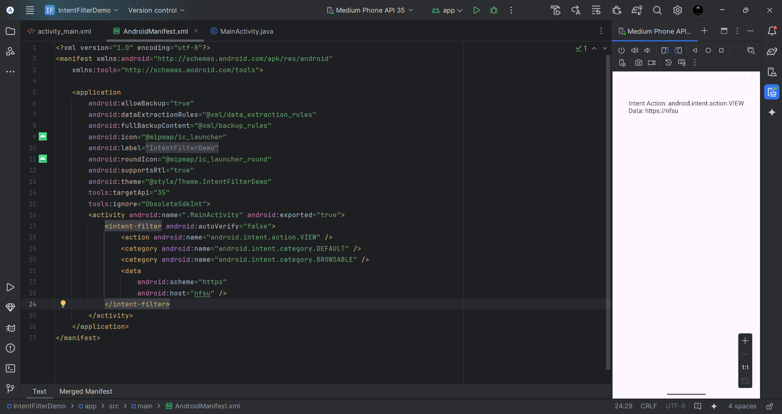

1. **Demonstration of Android Content Provider**

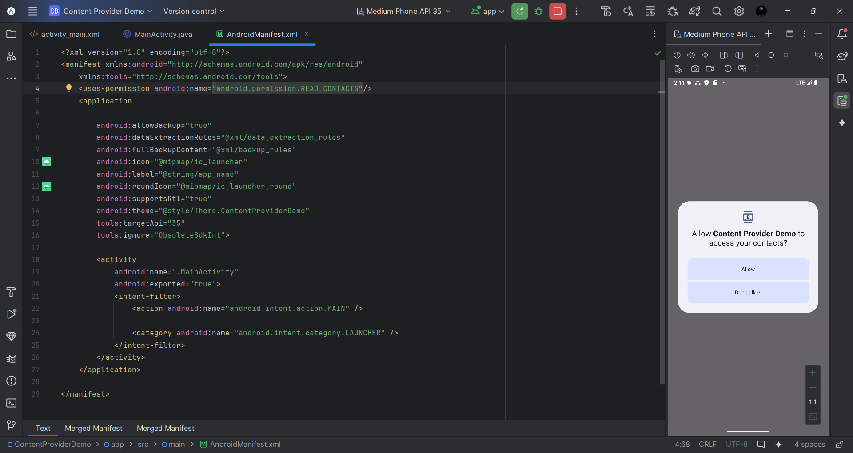

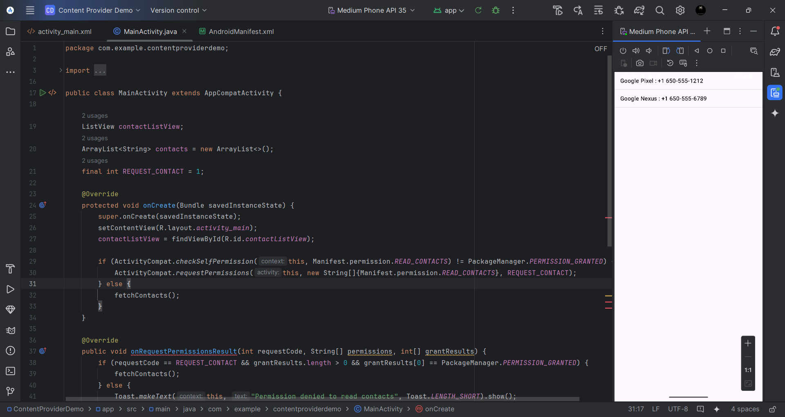

1. **Demonstration of Android Broadcast Receiver**

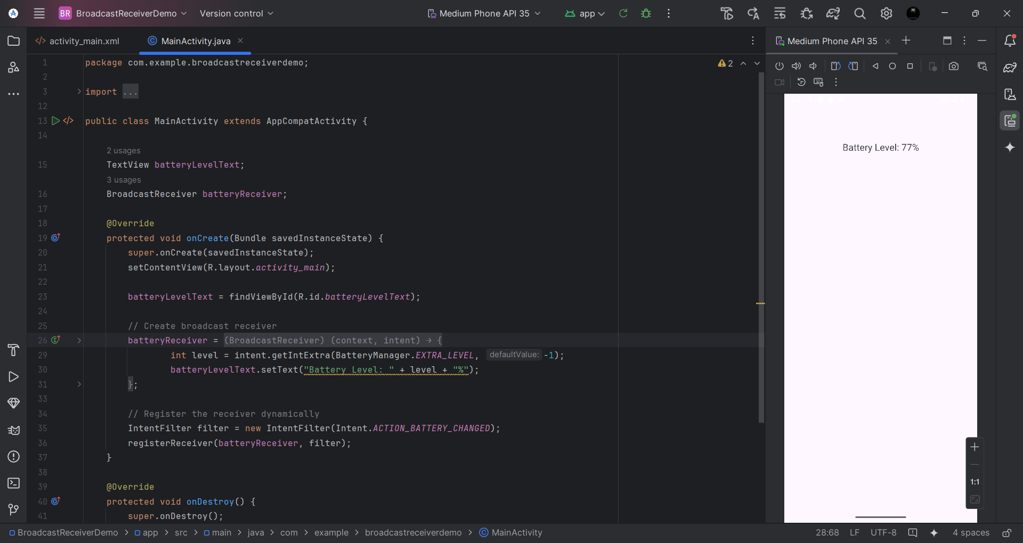

1. **Demonstration of Android Security Permission Model**

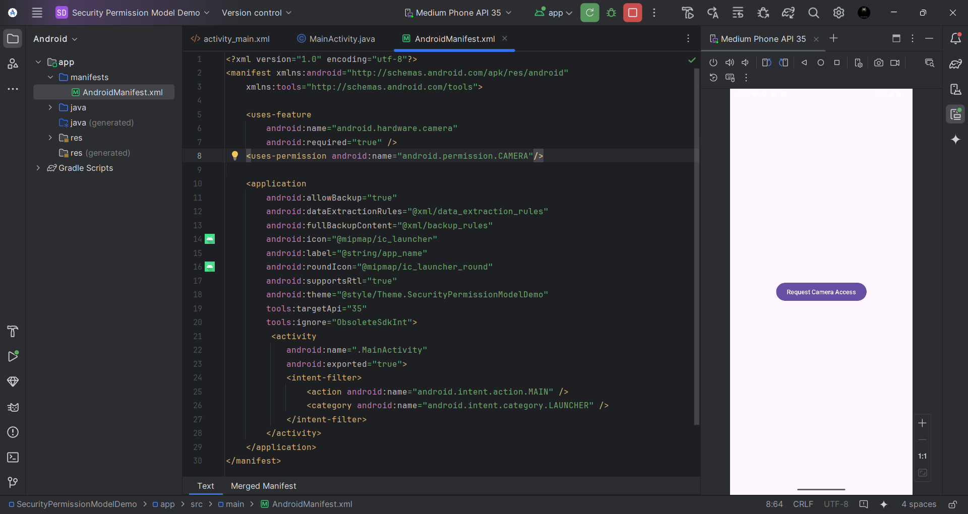

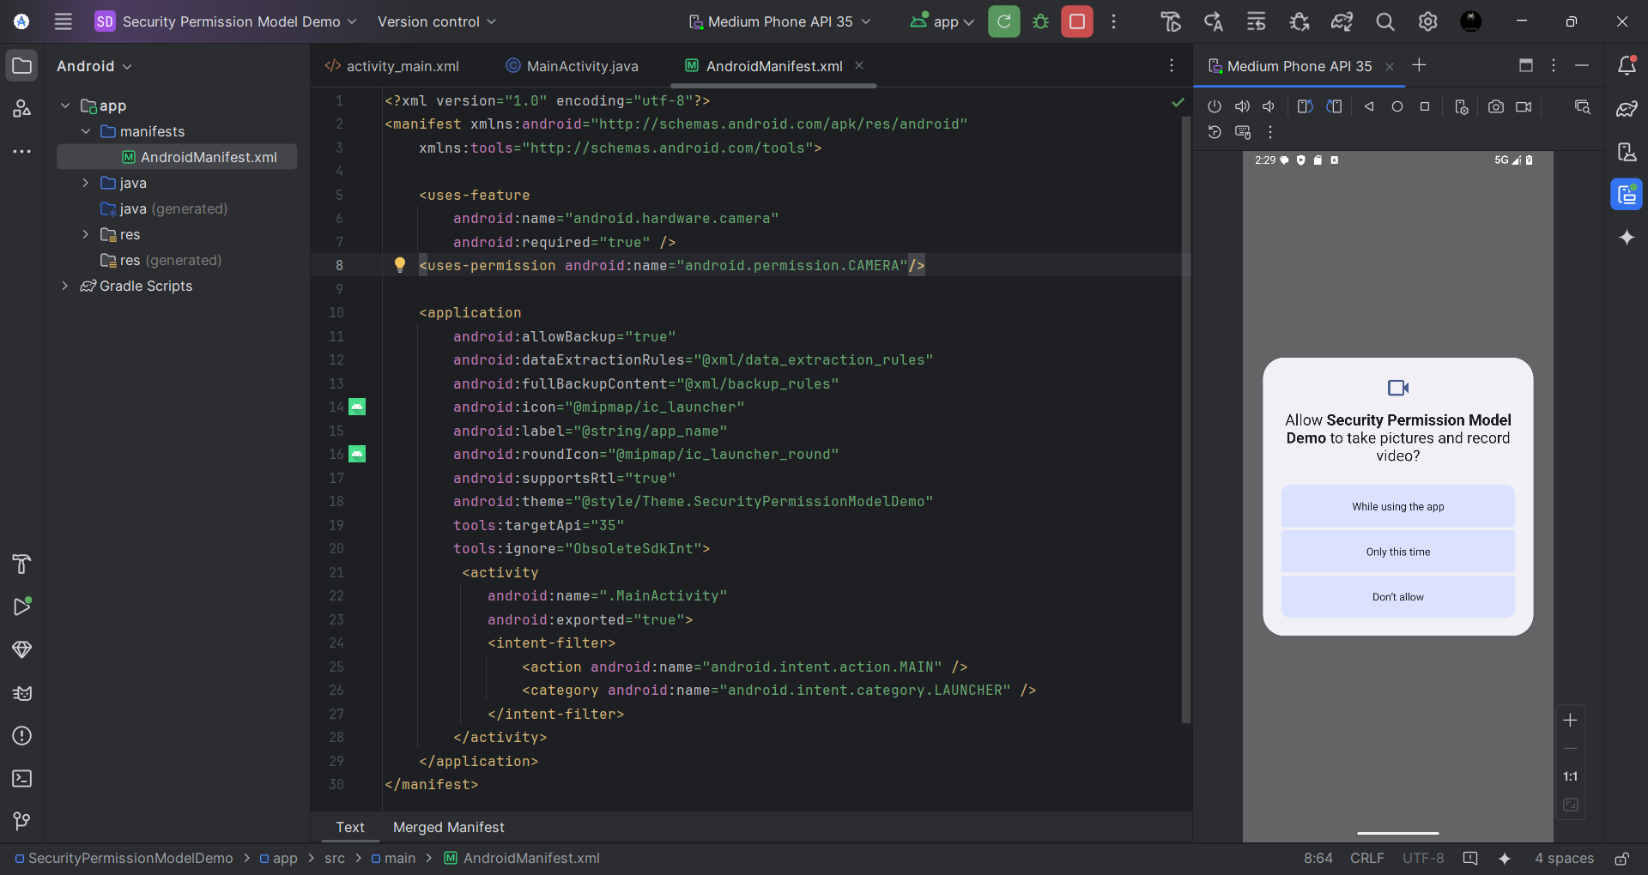

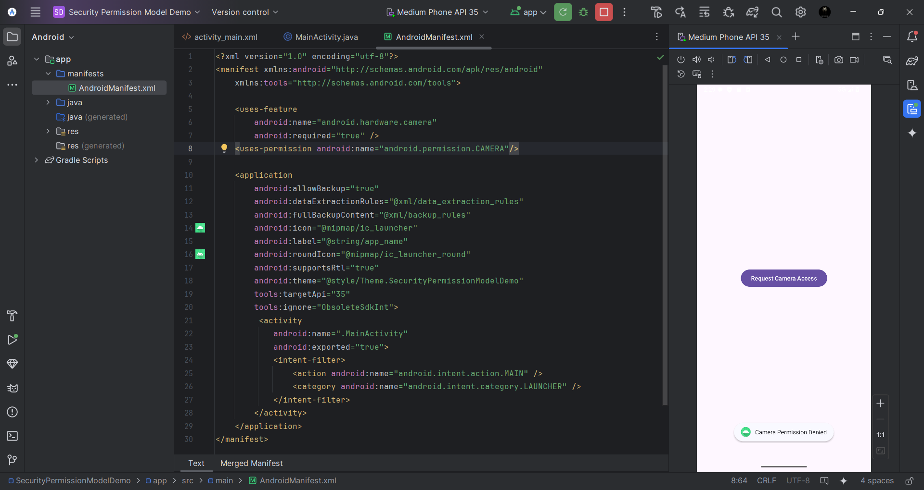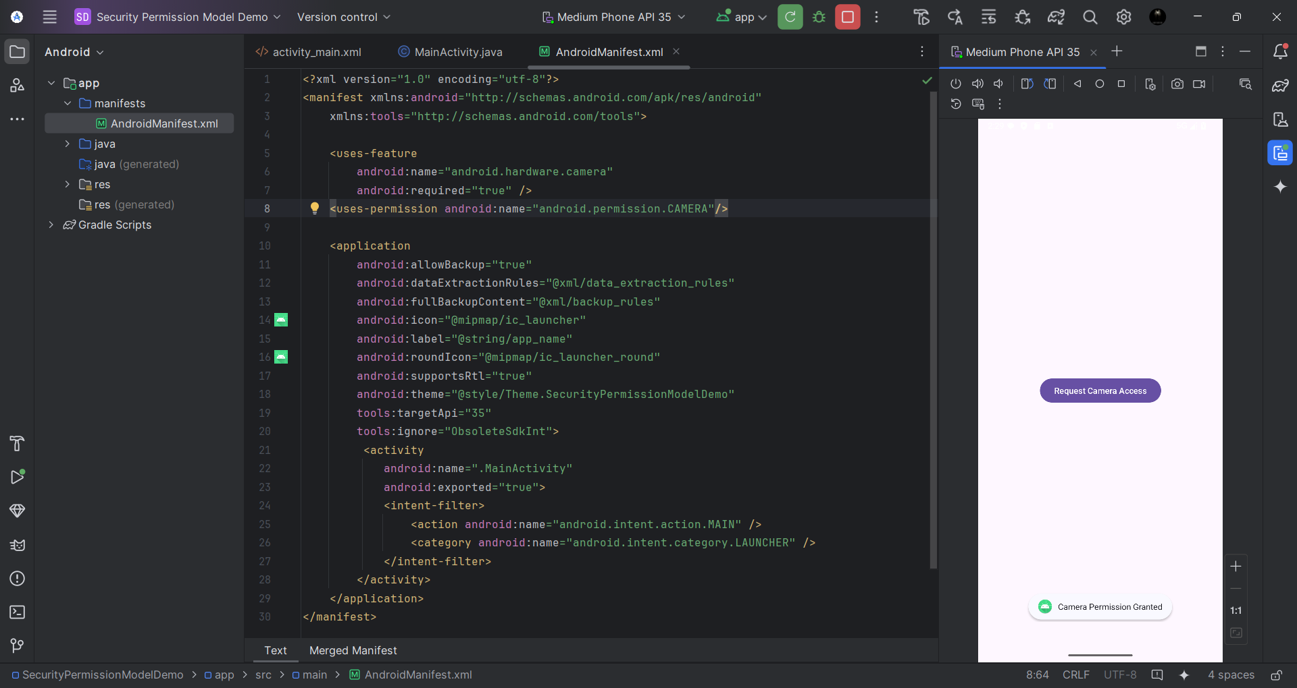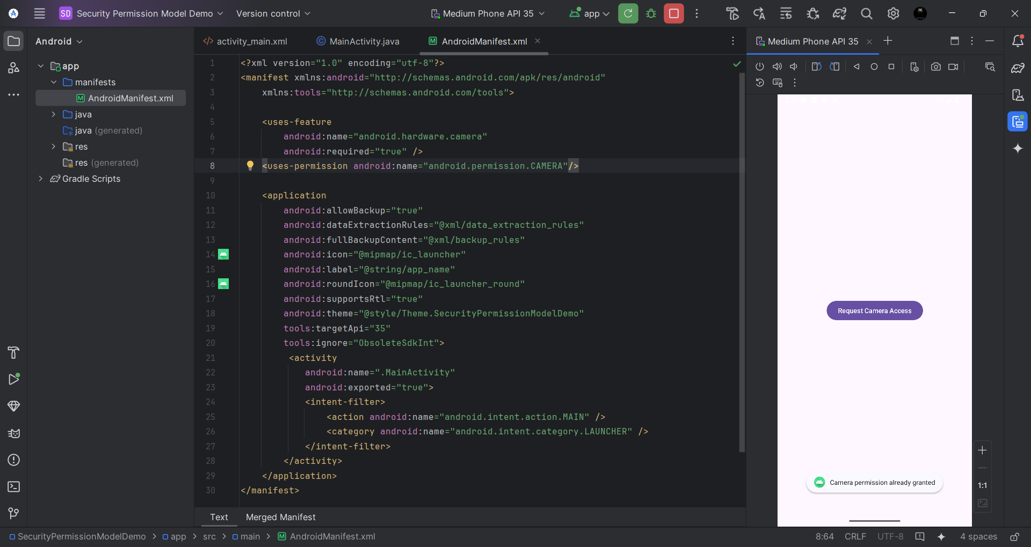

1. **Demonstration of Android Services**

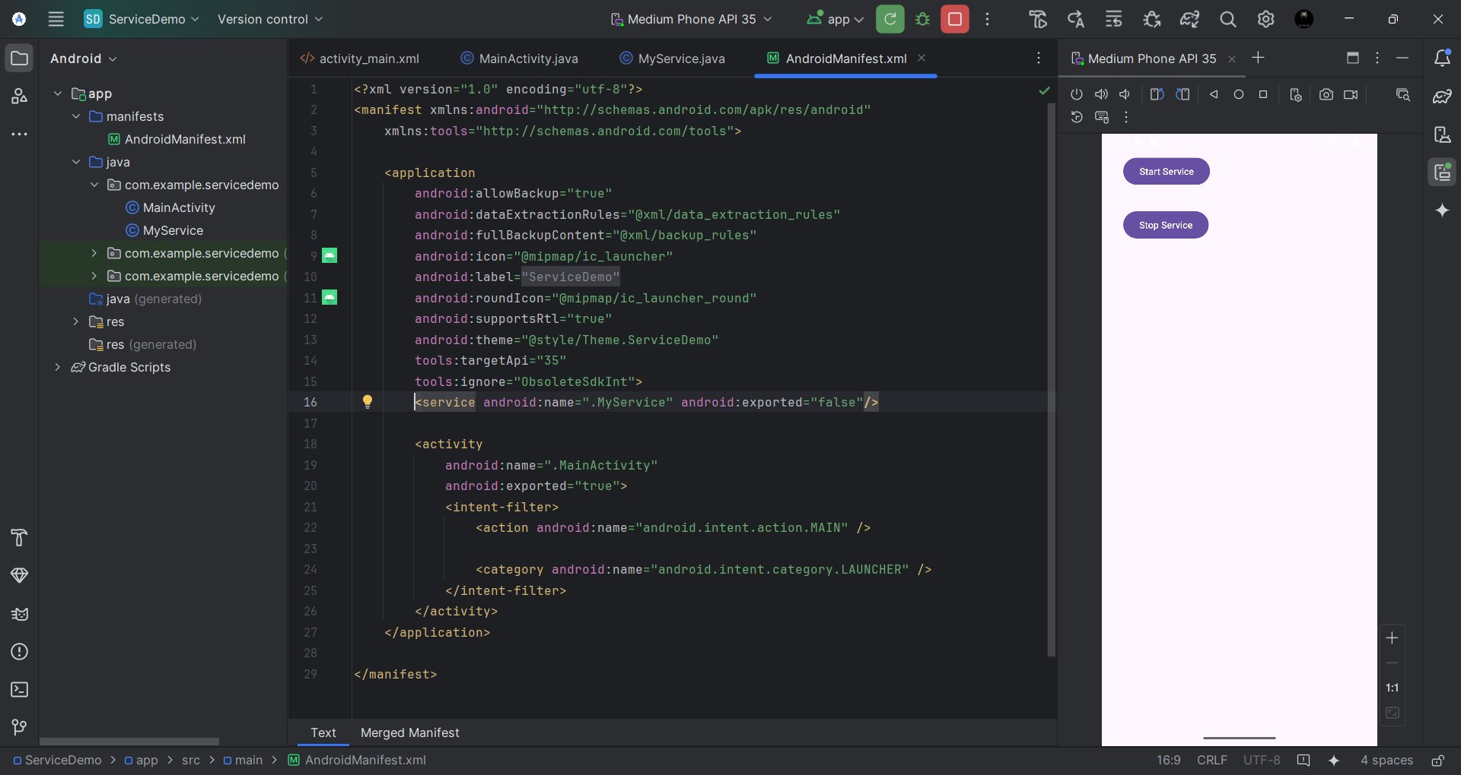

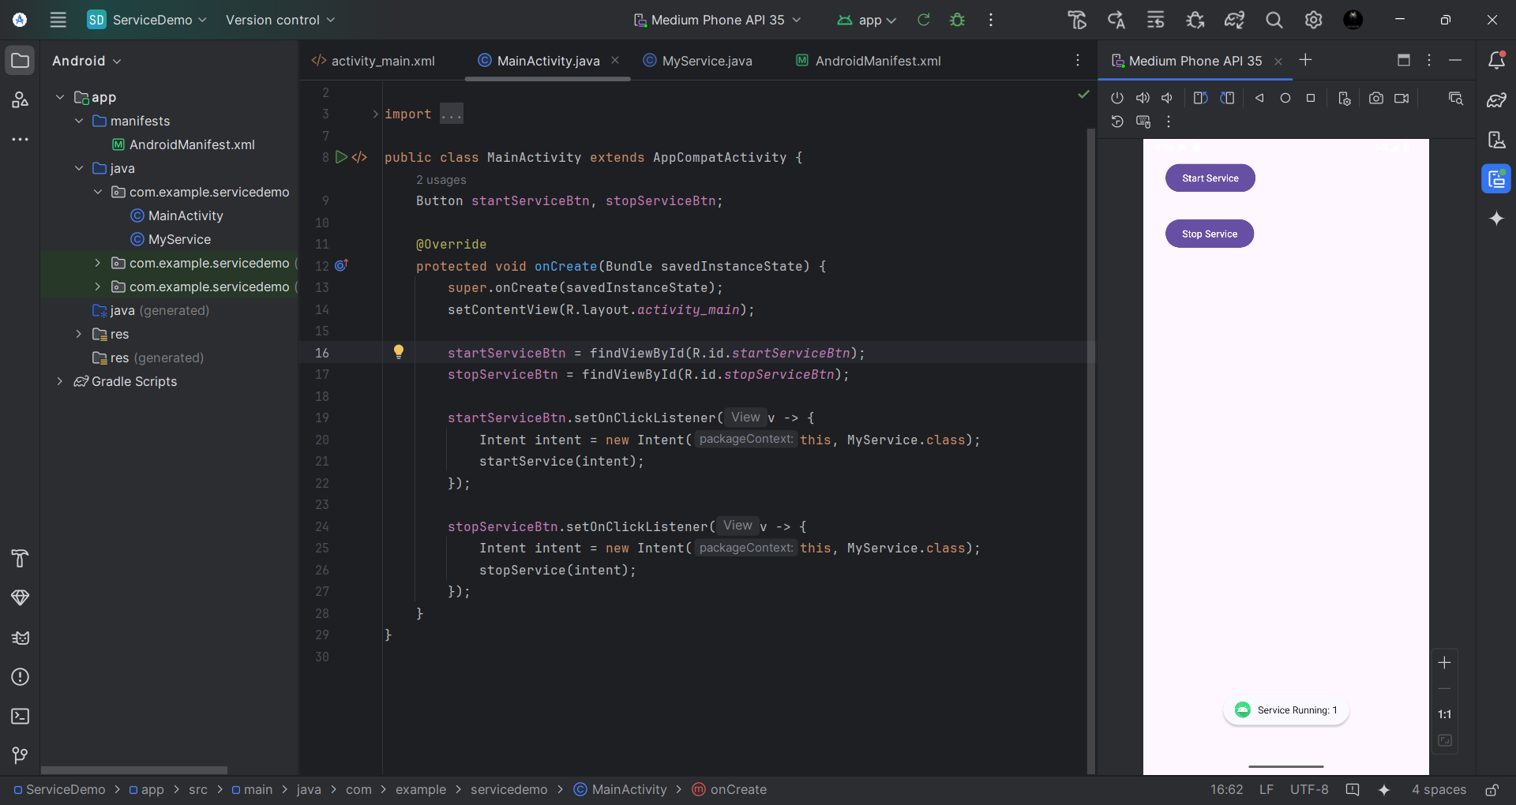 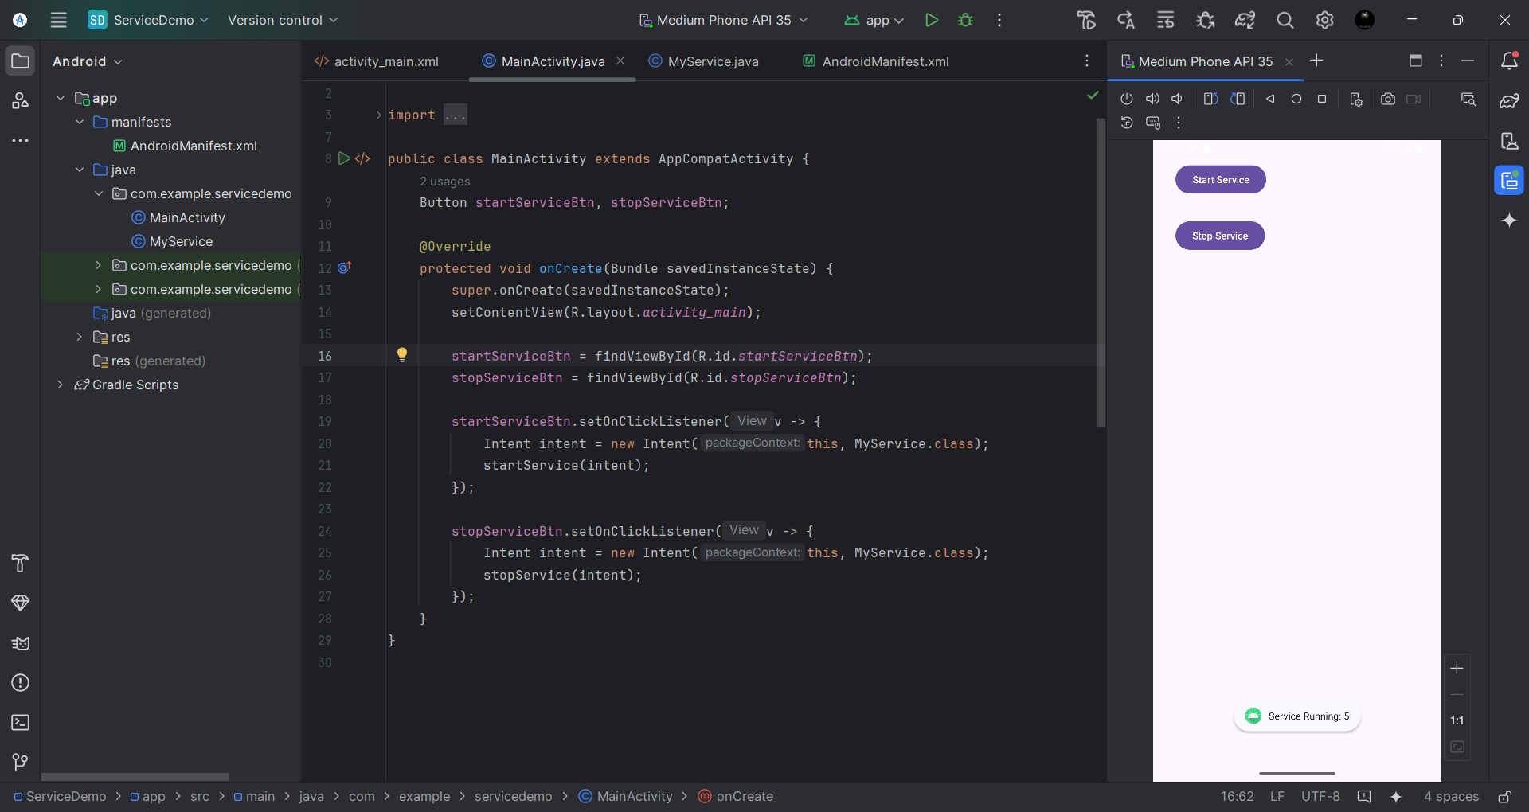 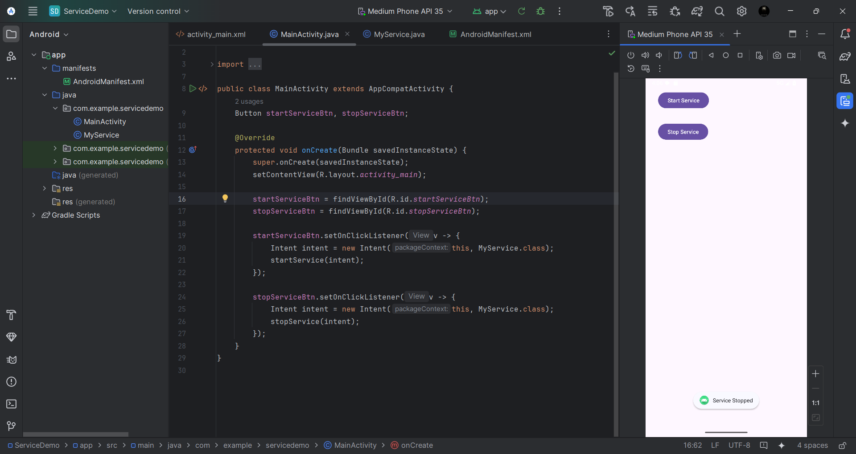

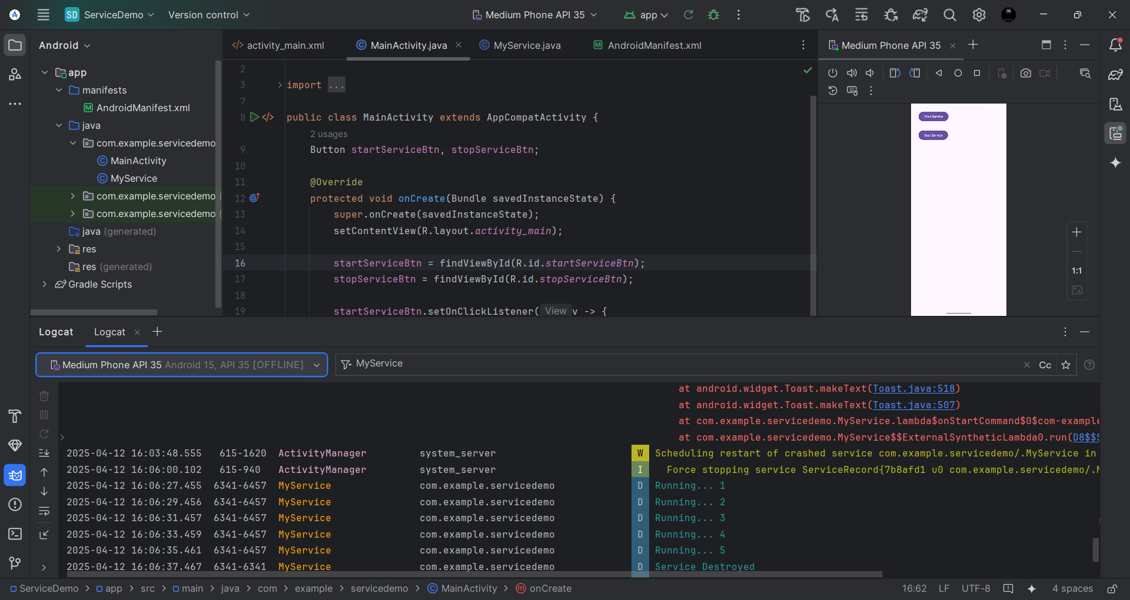

1. **Configuration of Santoku OS**

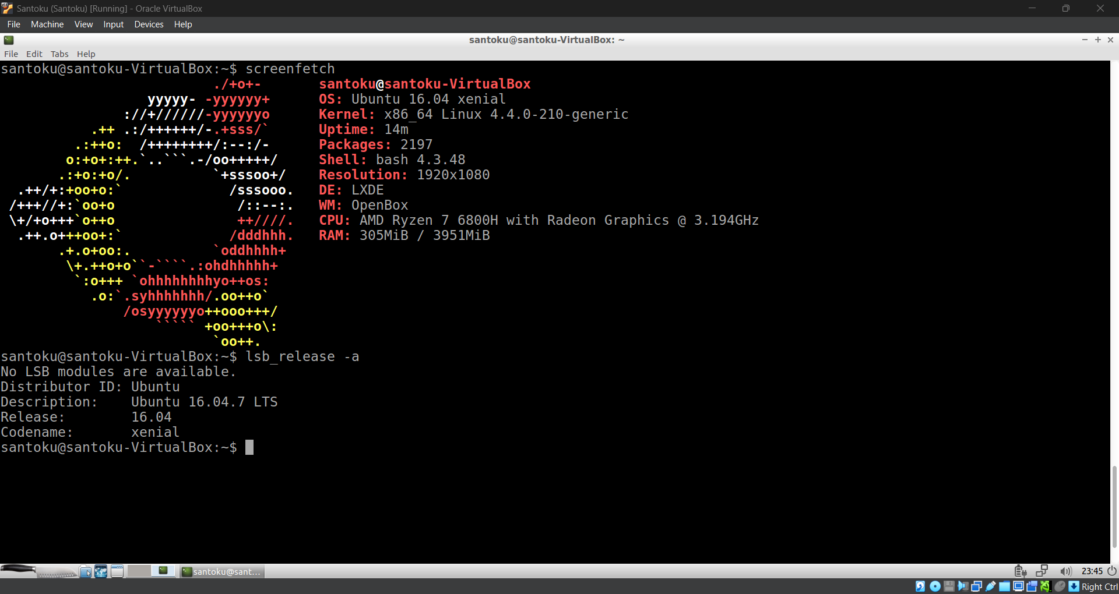

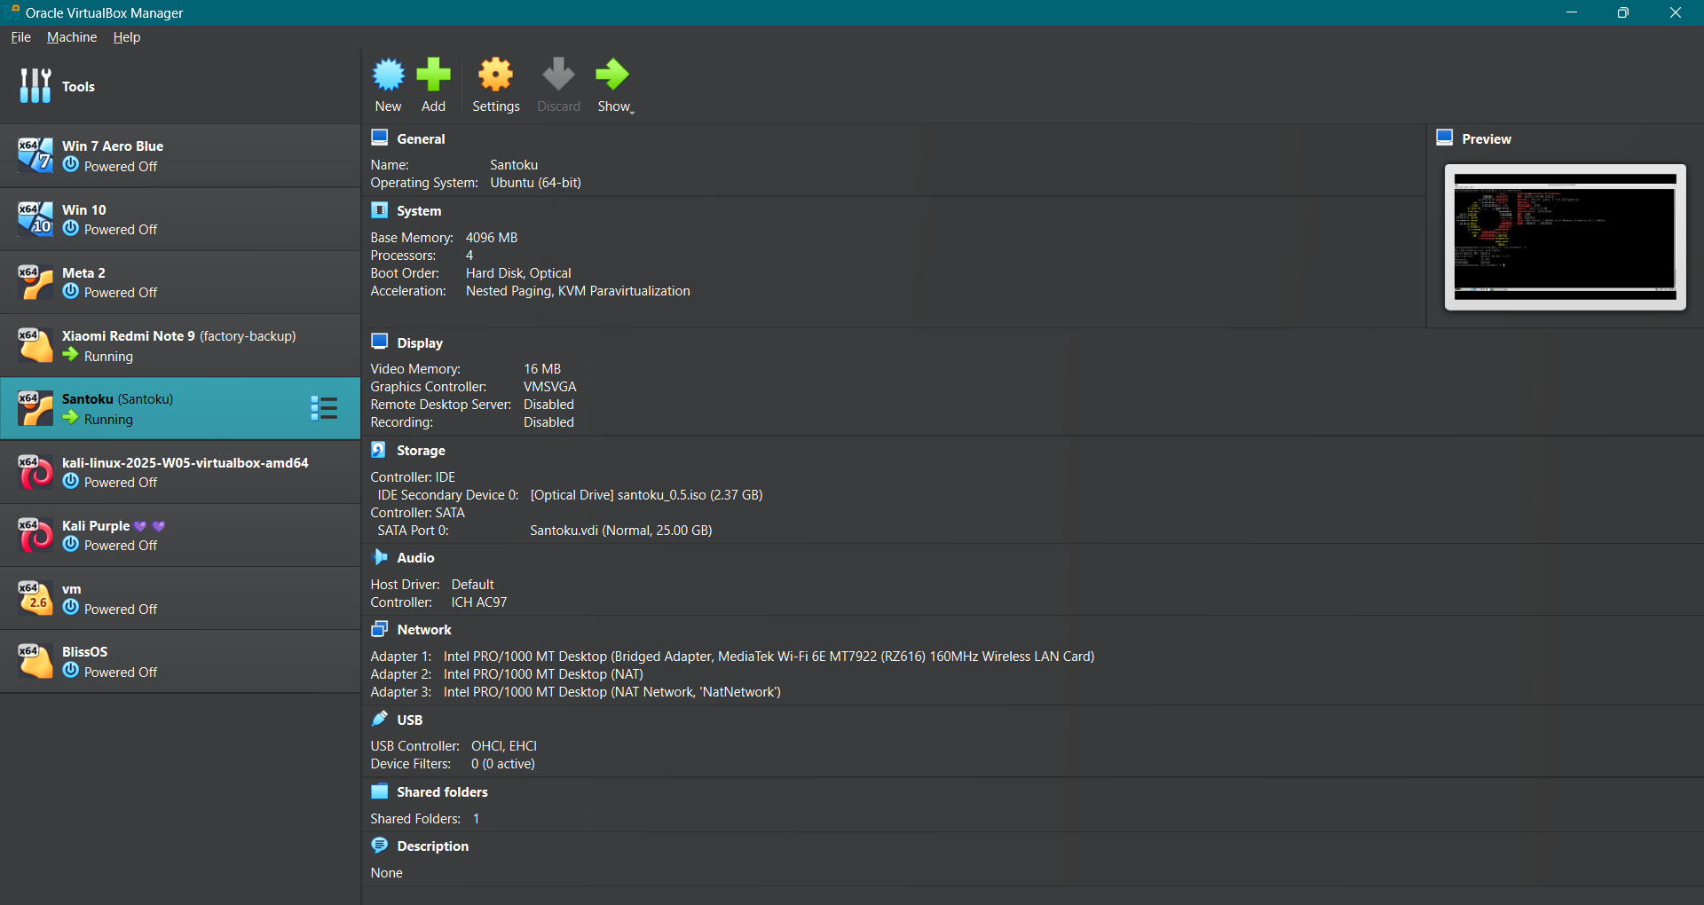

1. **Configuration of Genymotion**

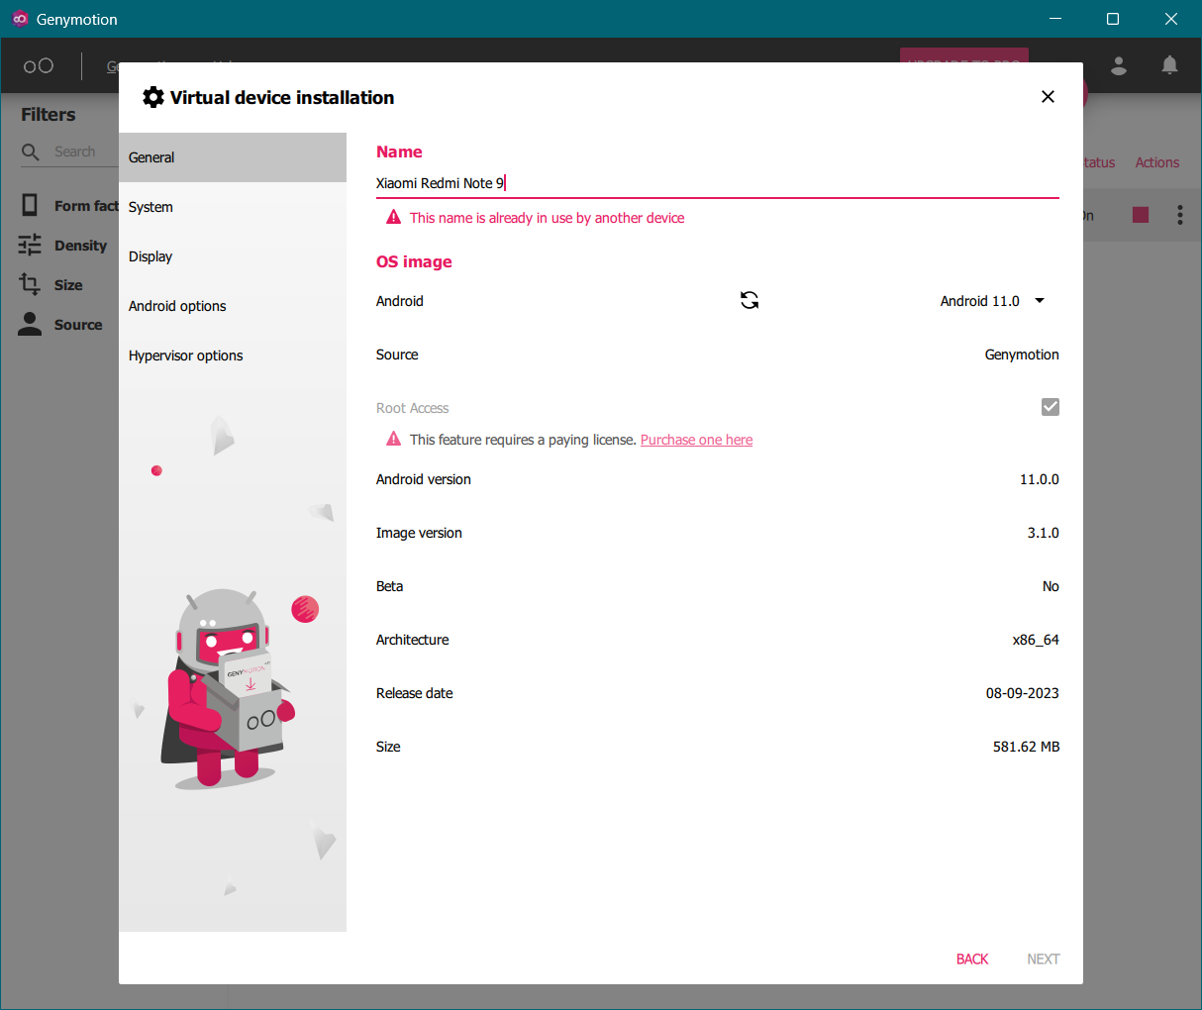

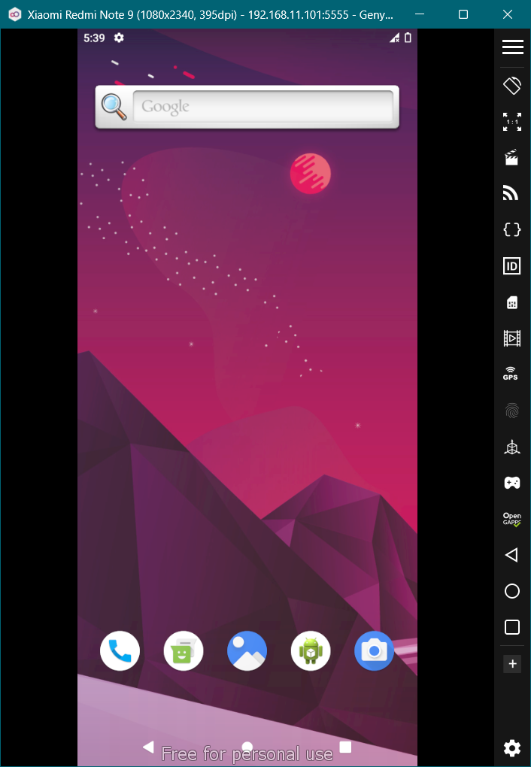 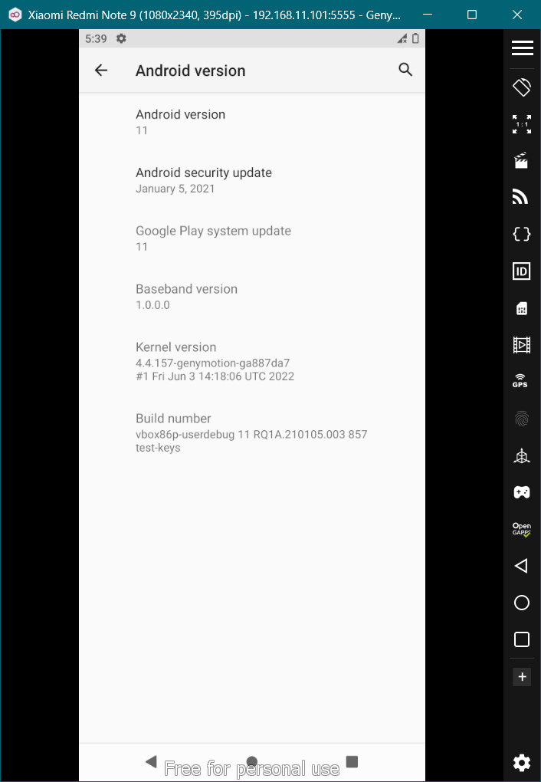

1. **Demonstration of ADB commands**

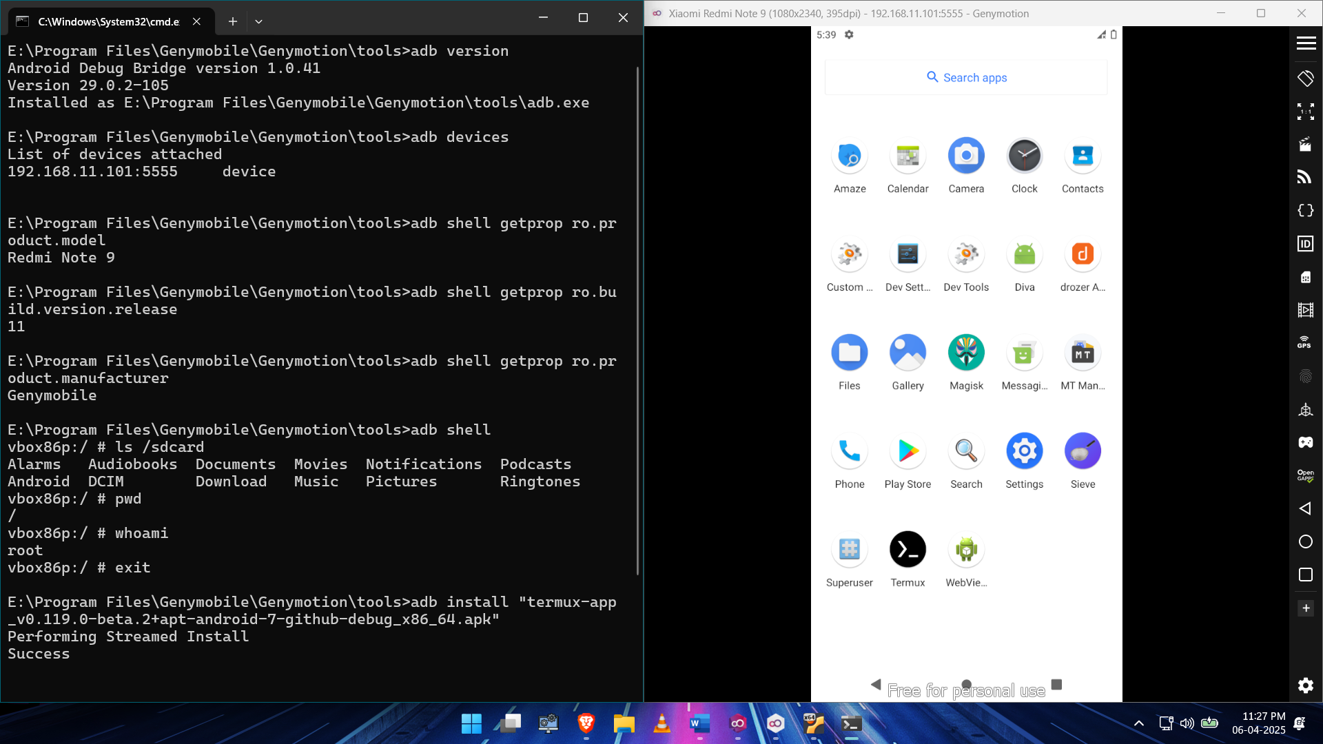

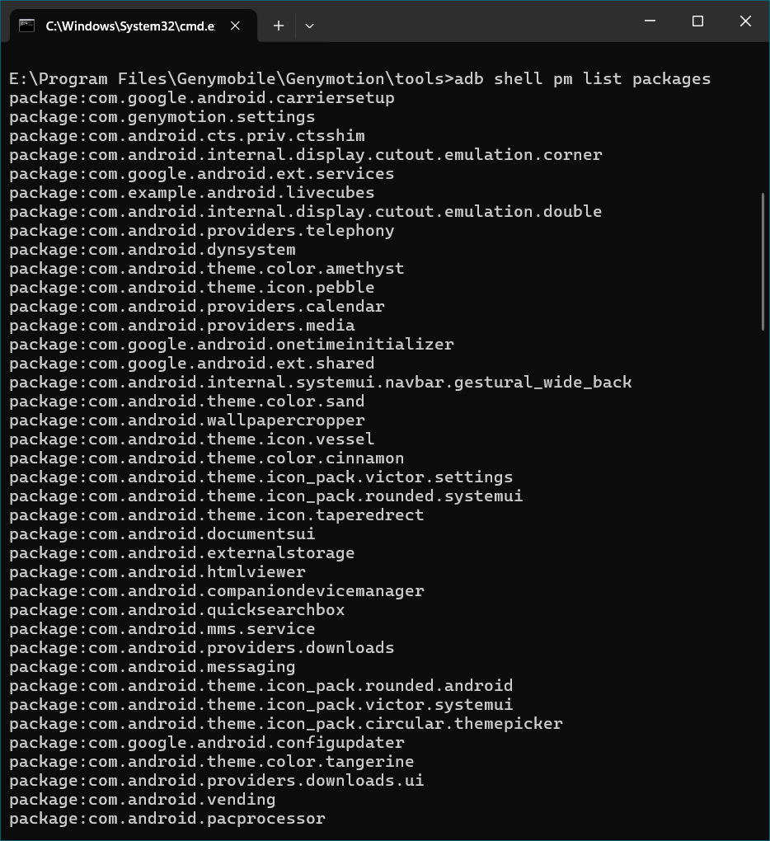

1. **Demonstration of Android Boot Process using ADB**

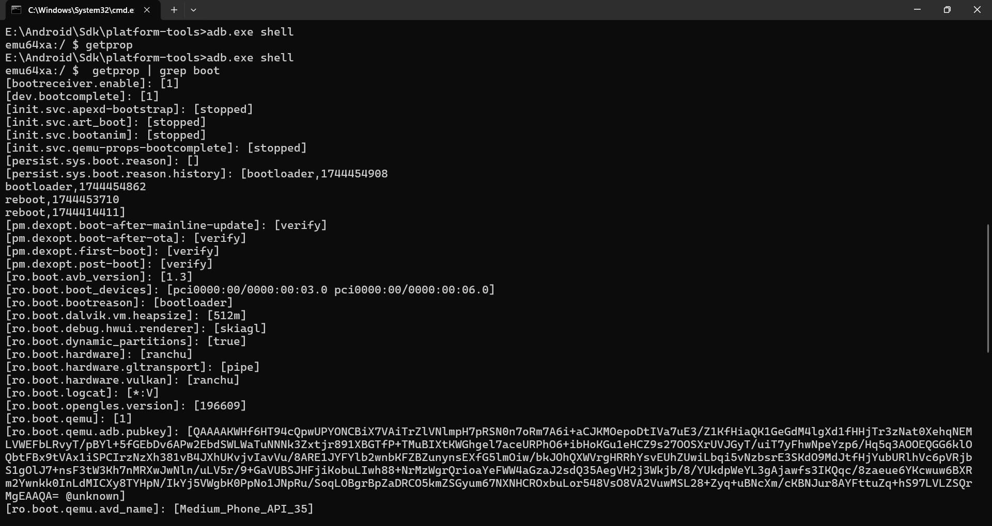

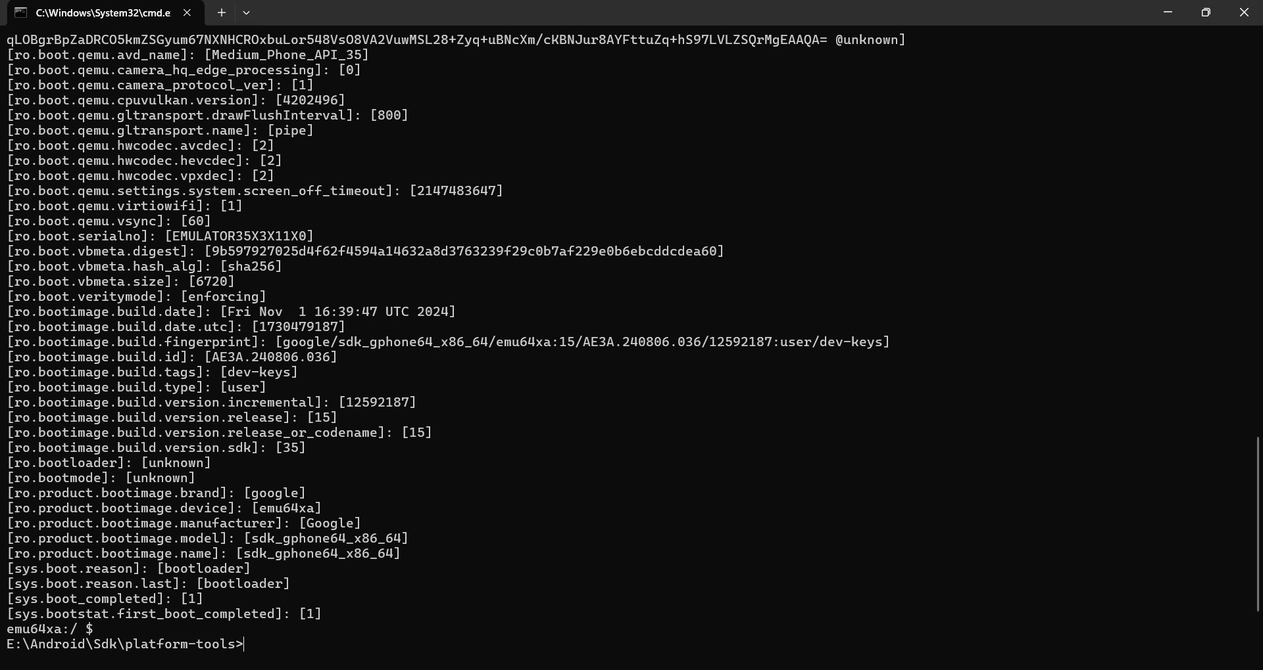

1. **Configuration of DIVA**

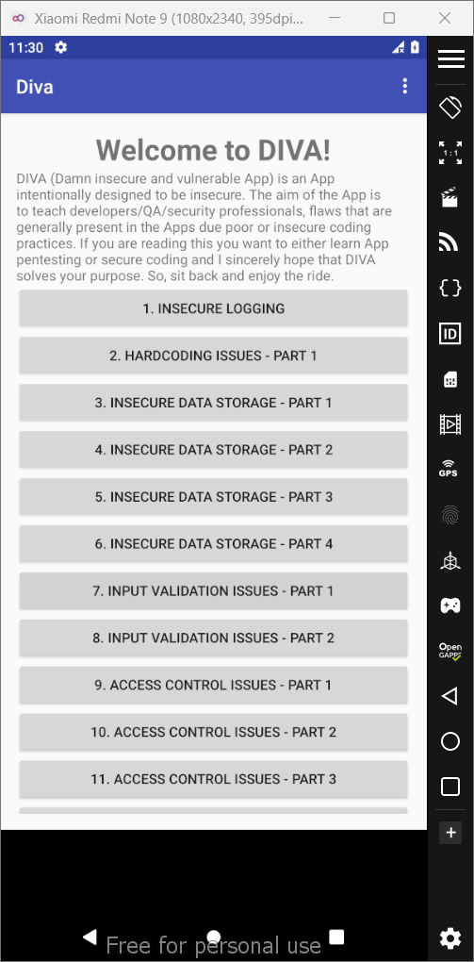

1. **Reverse Engineering using APKTools**

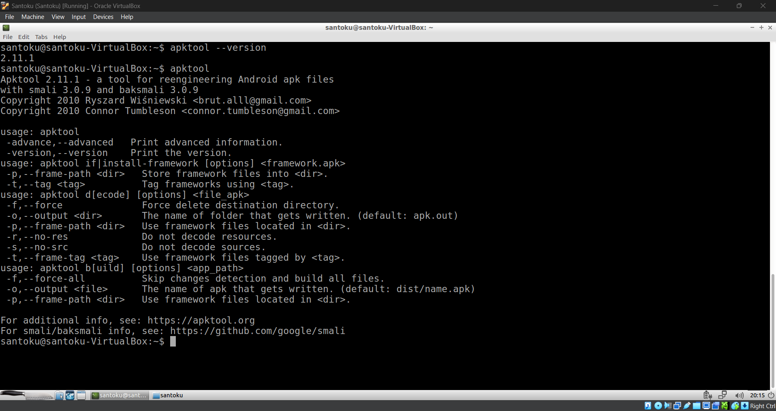

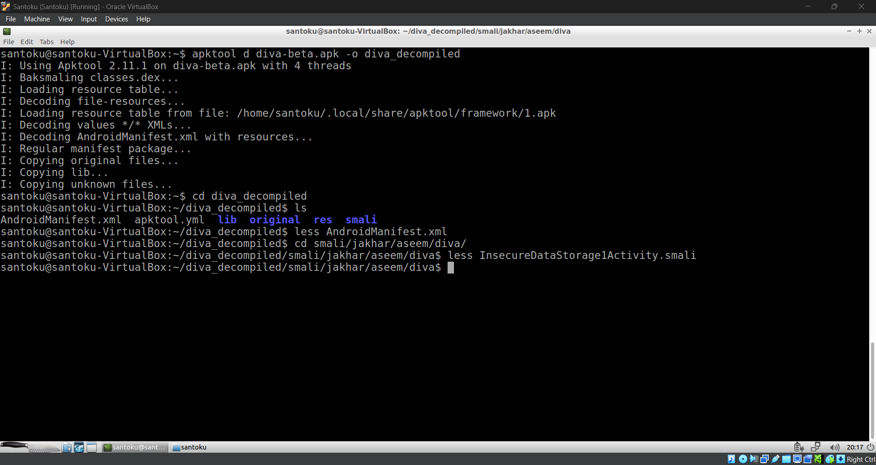

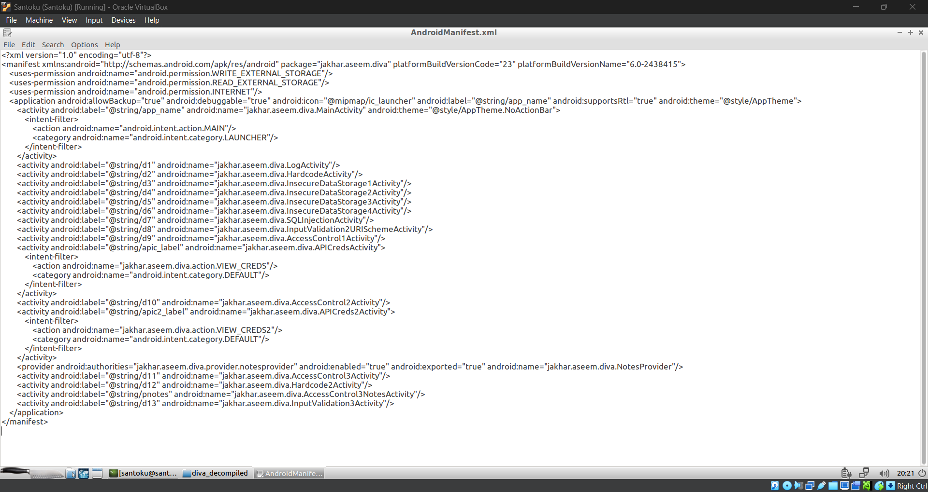

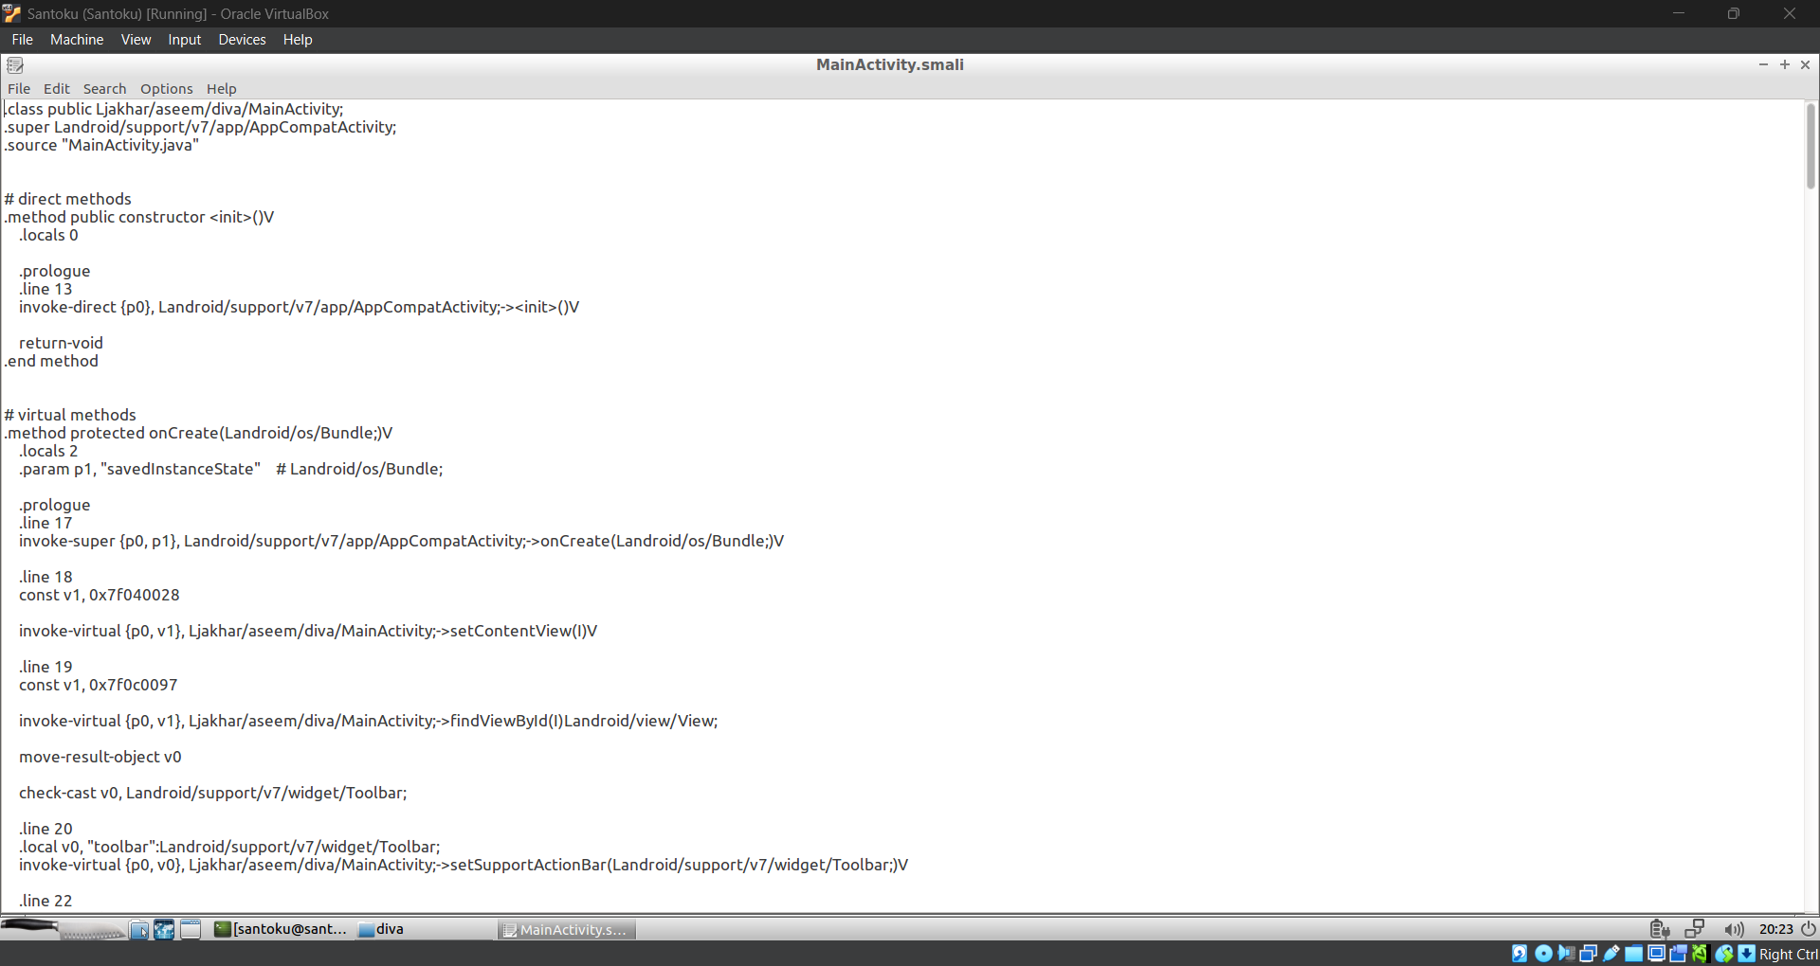

1. **Reverse Engineering using Haxdump Dex Dump and d2j**

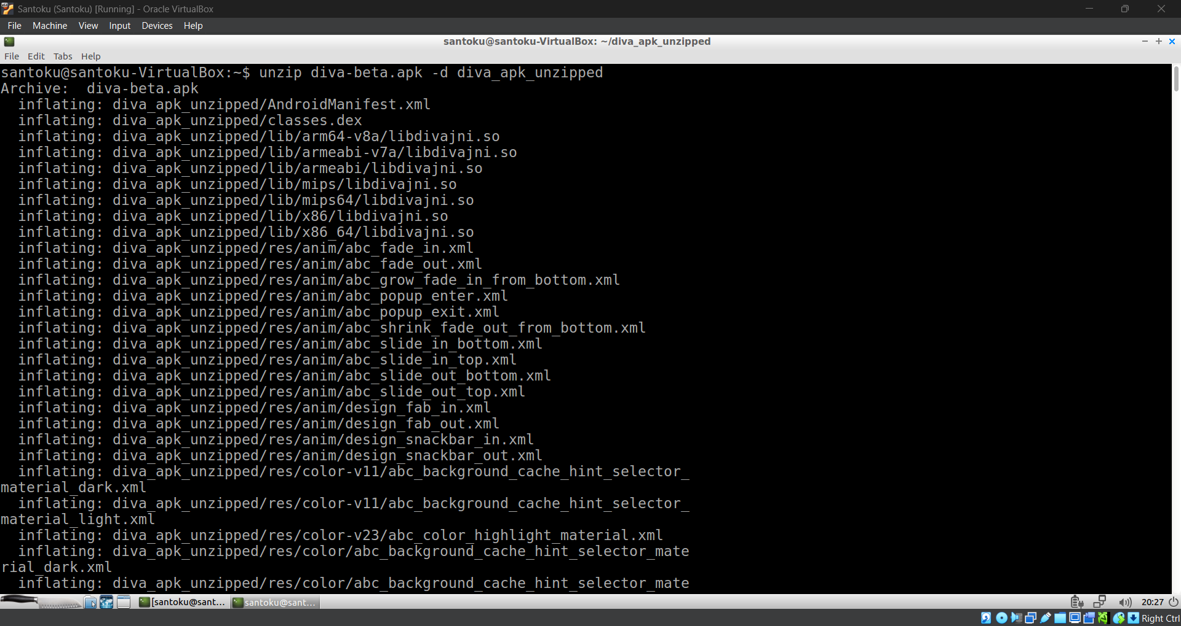

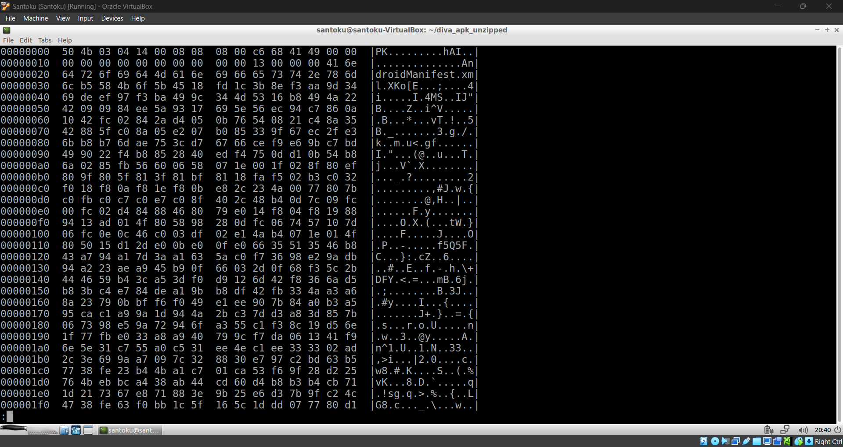

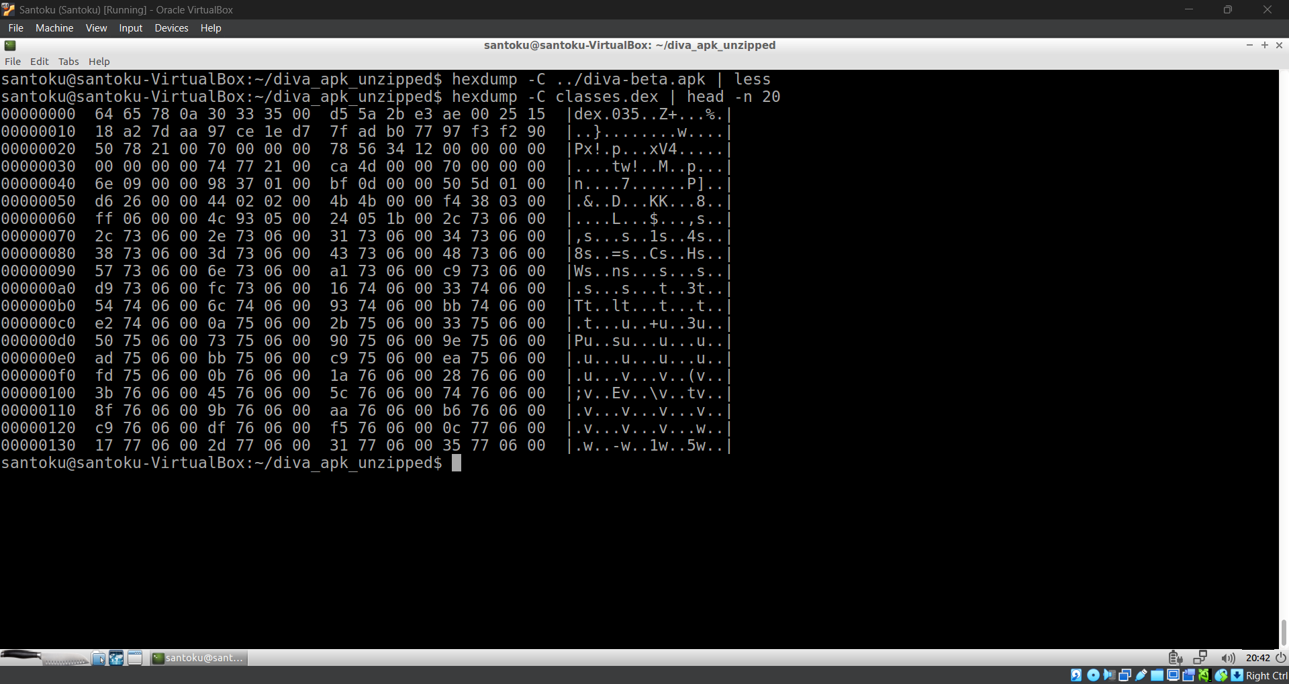

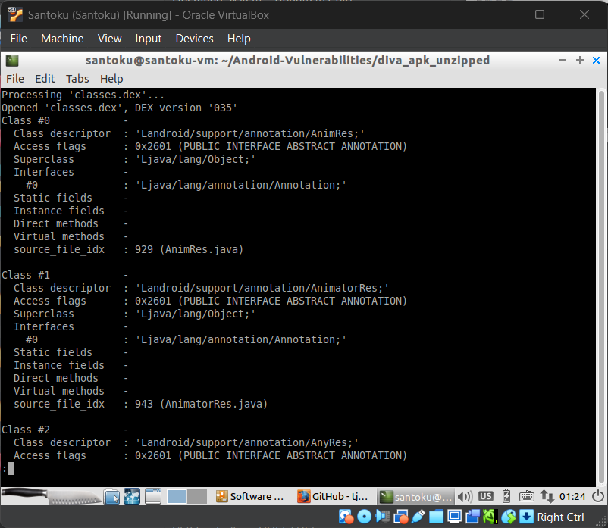

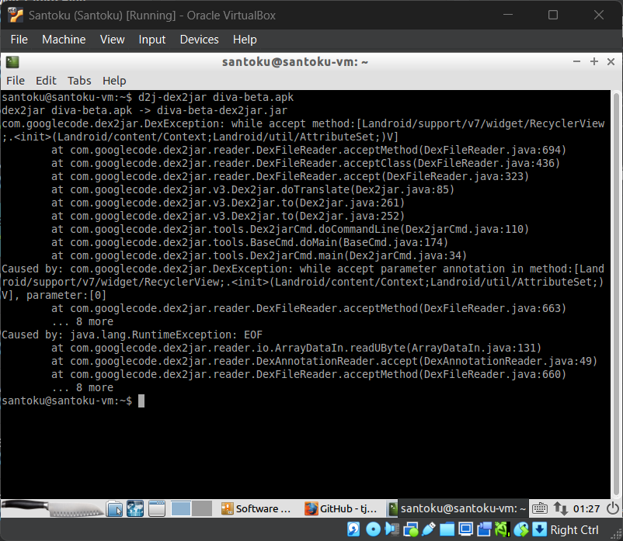

1. **Reverse Engineering using dex2jar and JDGUI**

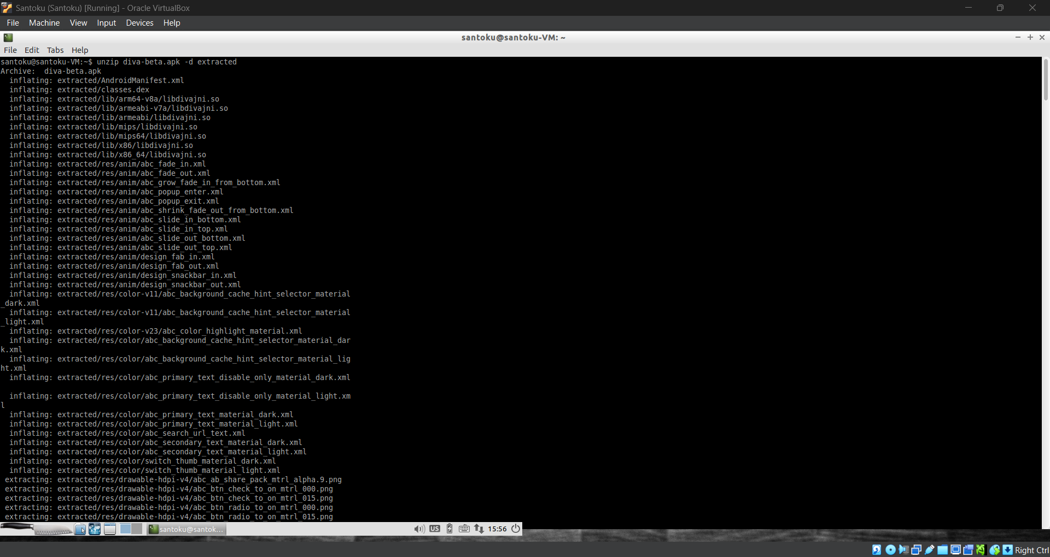

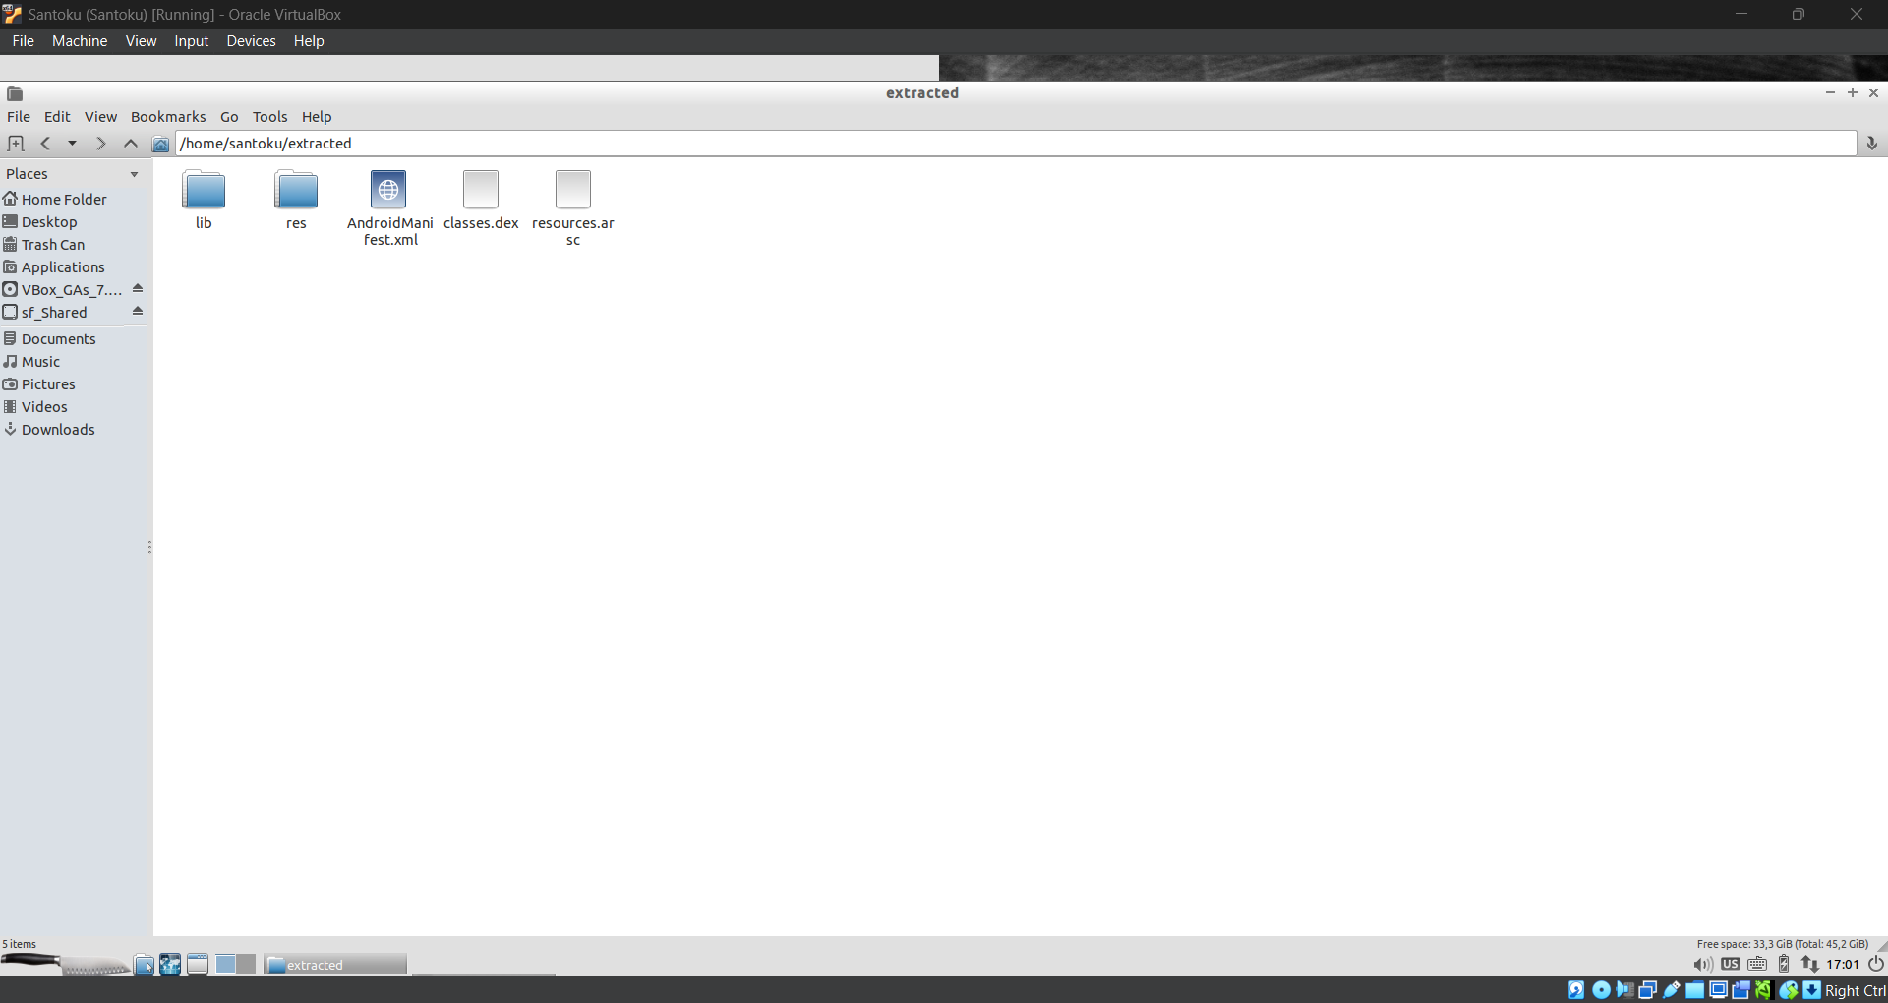

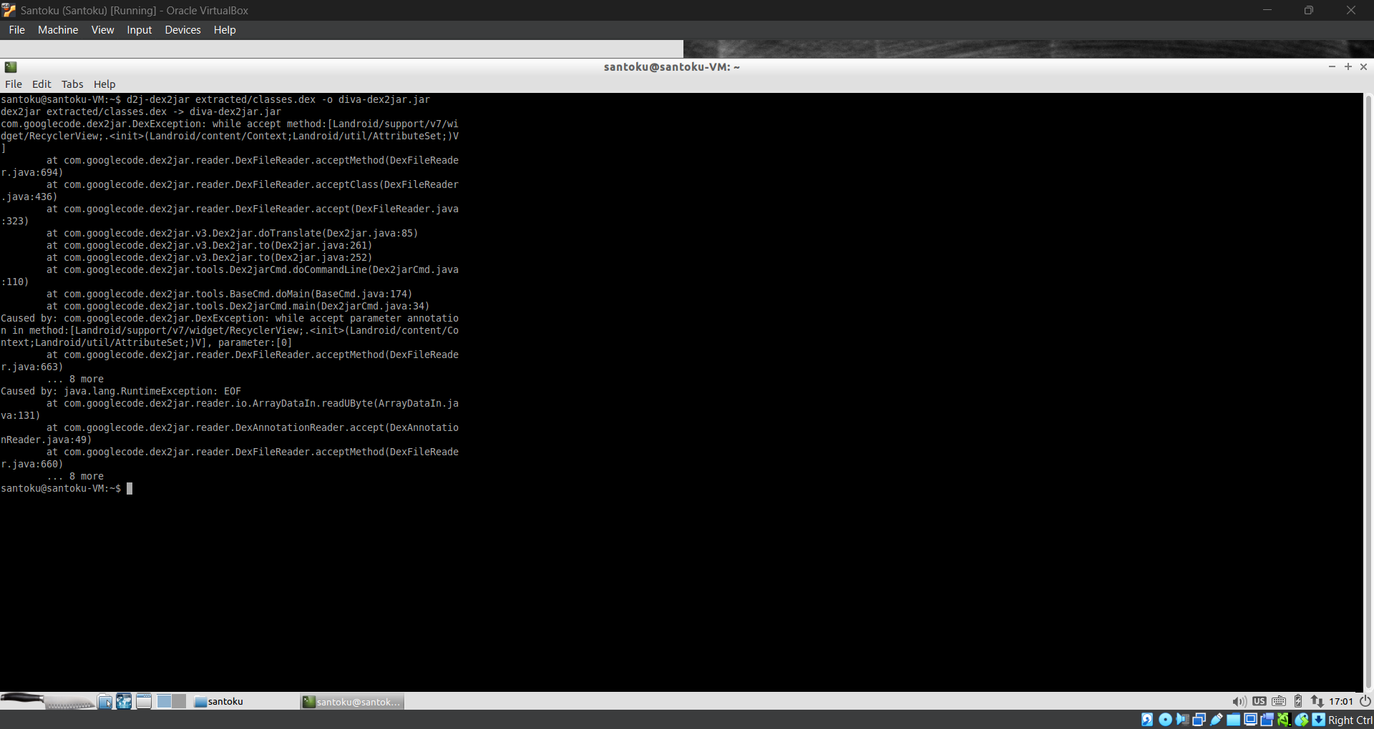

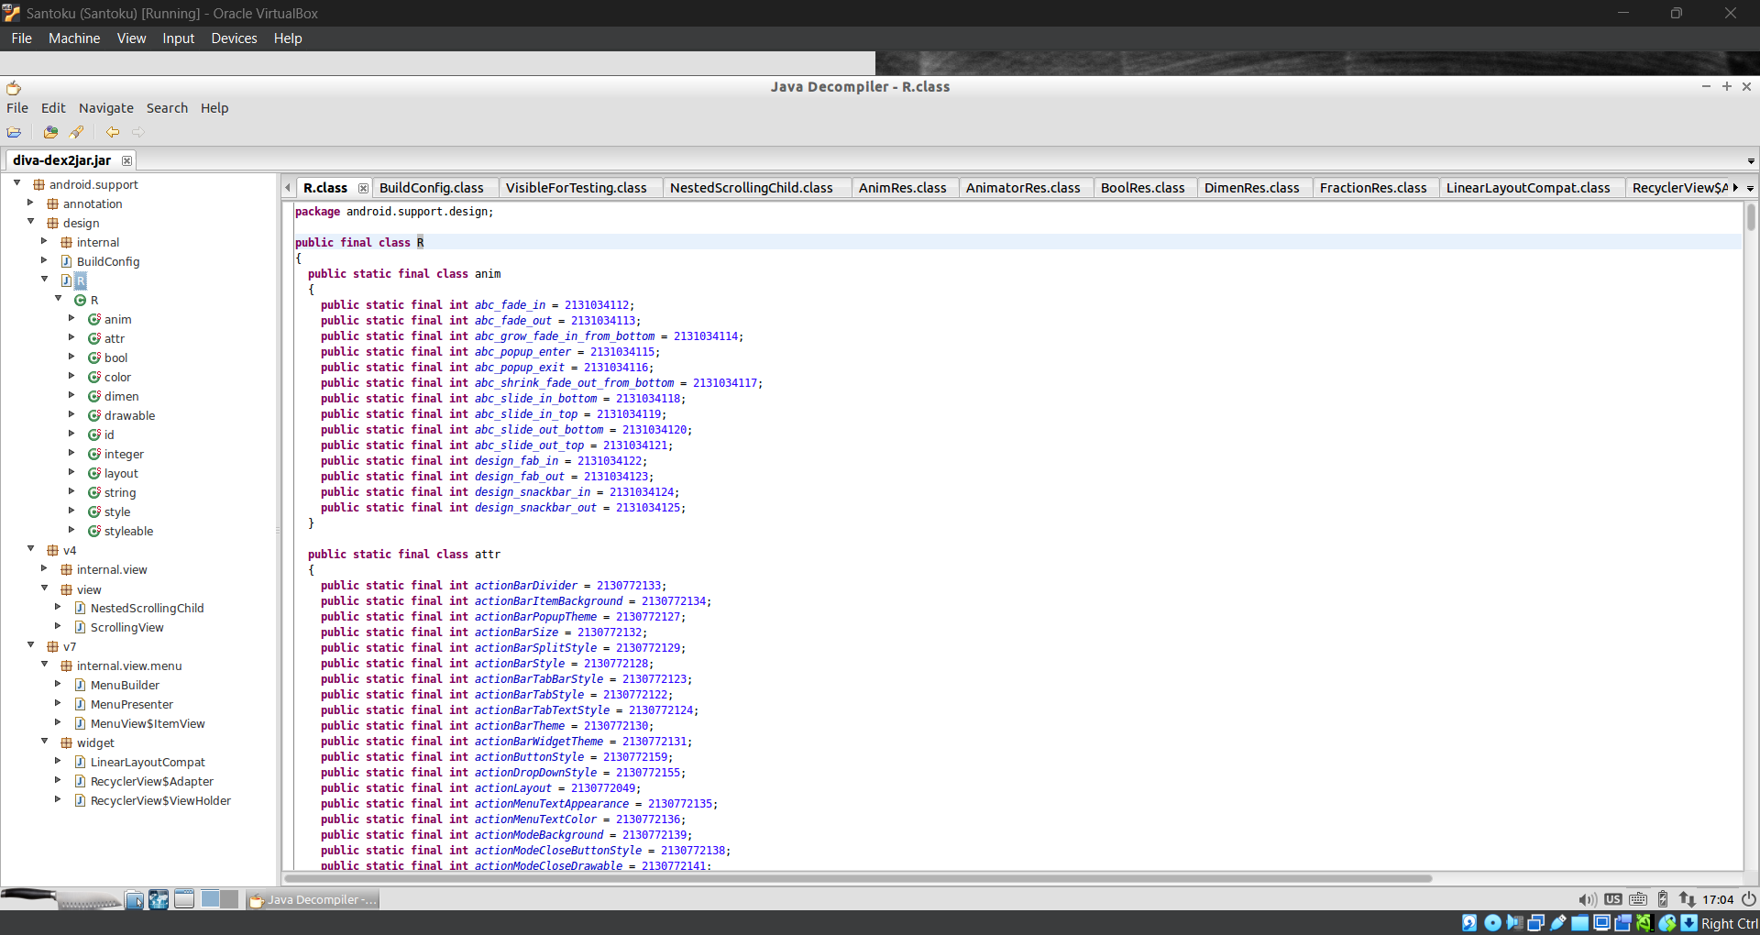

1. **Request interception using BurpSuit**

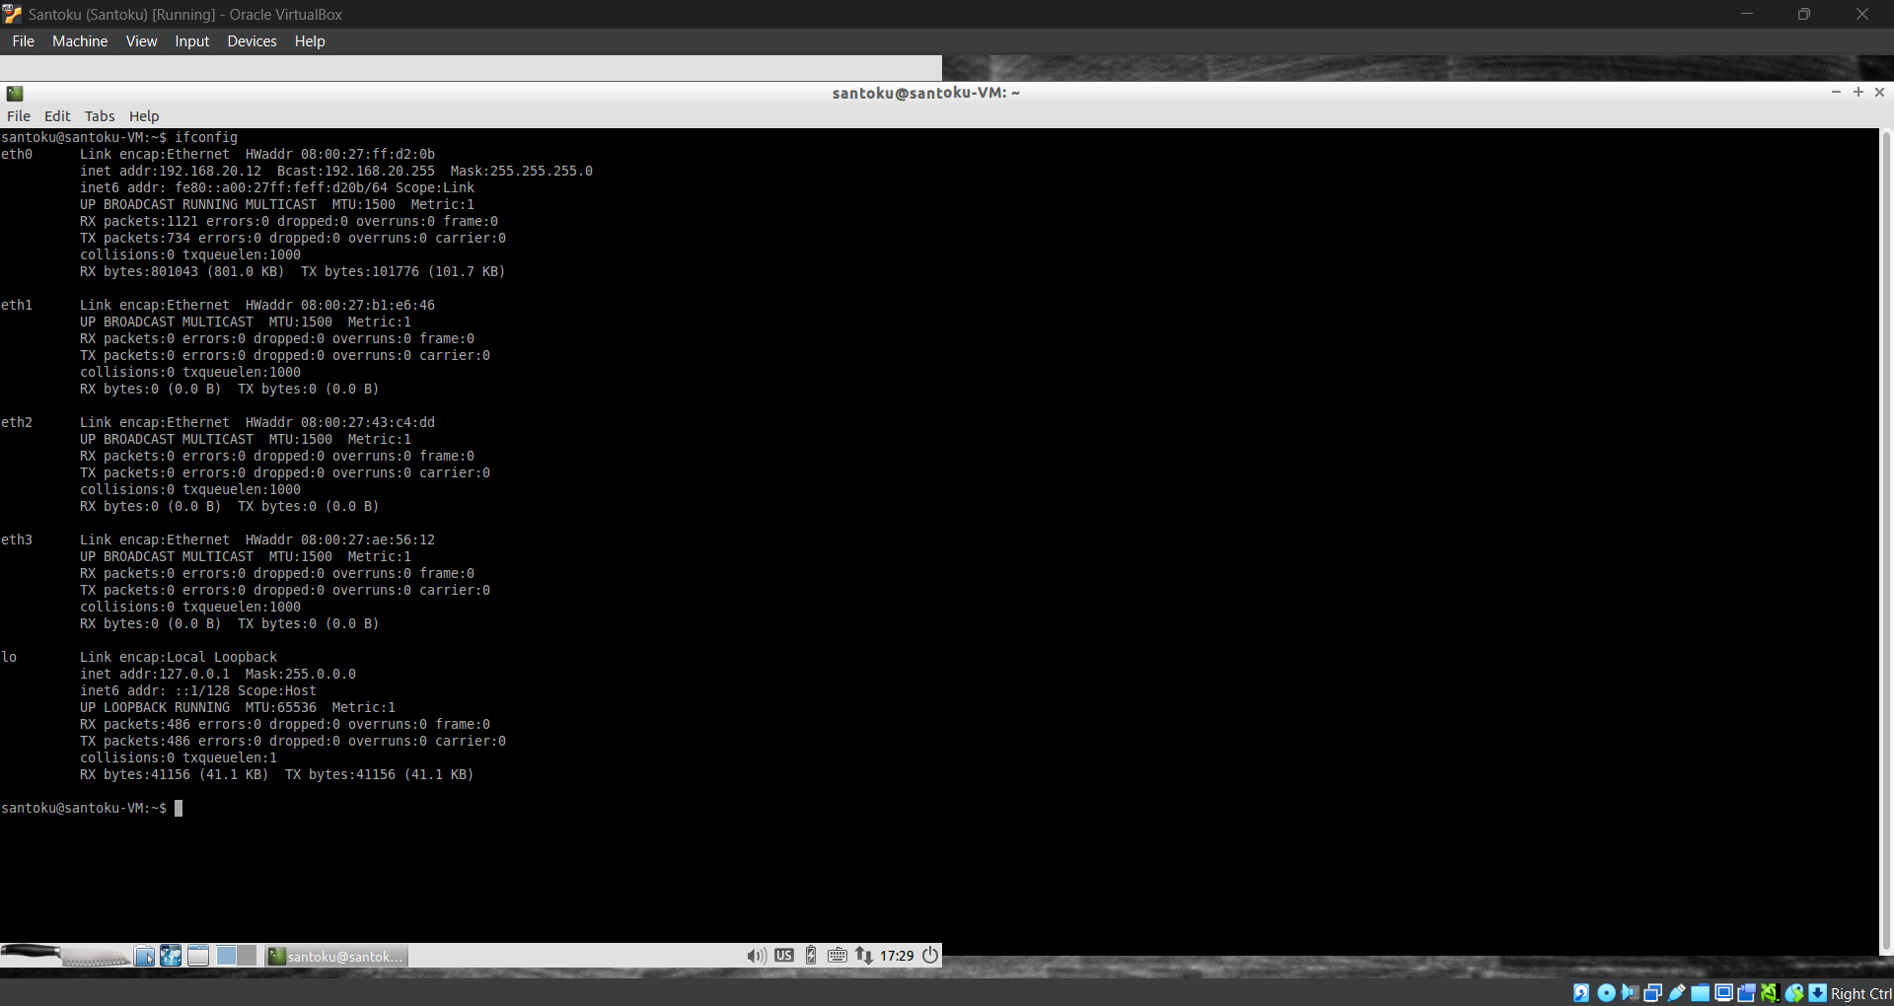

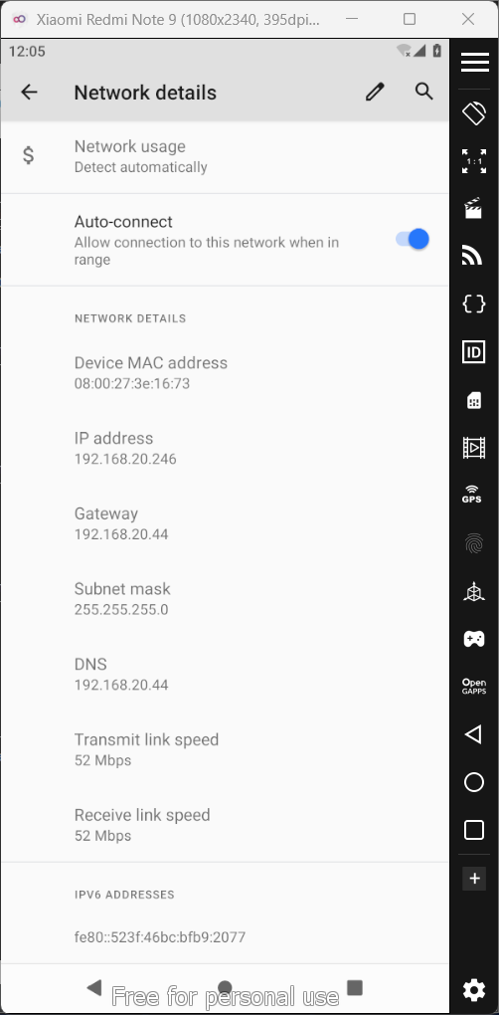

1. **Configuration of Insecure Bank2**
2. **Configuration of OWASP GoatDroid**
3. **Configuration of Open GApps**
4. **Insecure Logging – Vulnerability**
5. **Hard Coding Issue – Vulnerability**
6. **Insecure Data Storage (Shared Preference) – Vulnerability**
7. **Insecure Data Storage (SD Card) – Vulnerability**
8. **Insecure Data Storage (Temp File) – Vulnerability**
9. **Insecure Data Storage (SQLight Database) – Vulnerability**
10. **Input Validation and Data Sanitization (SQL Injection) – Vulnerability**
11. **Input Validation and Data Sanitization (Web View) – Vulnerability**
12. **Access Control Issue – Vulnerability**
13. **Authentication Based Access Control – Vulnerability**
14. **Configuration of Drozer**
15. **Security Auditing of DIVA using Drozer**
16. **Security Auditing of Insecure Bank using Drozer**
17. **Security Auditing of OWASP GoatDroid using Drozer**
18. **Package listing of android app using app.package.list**
19. **Find Debuggable android application**
20. **Find attack surface of DIVA**
21. **SQL Injection Vulnerability of DIVA using Drozer Modules**

1. **Configuration of MobSF (Mobile Security Framework)**

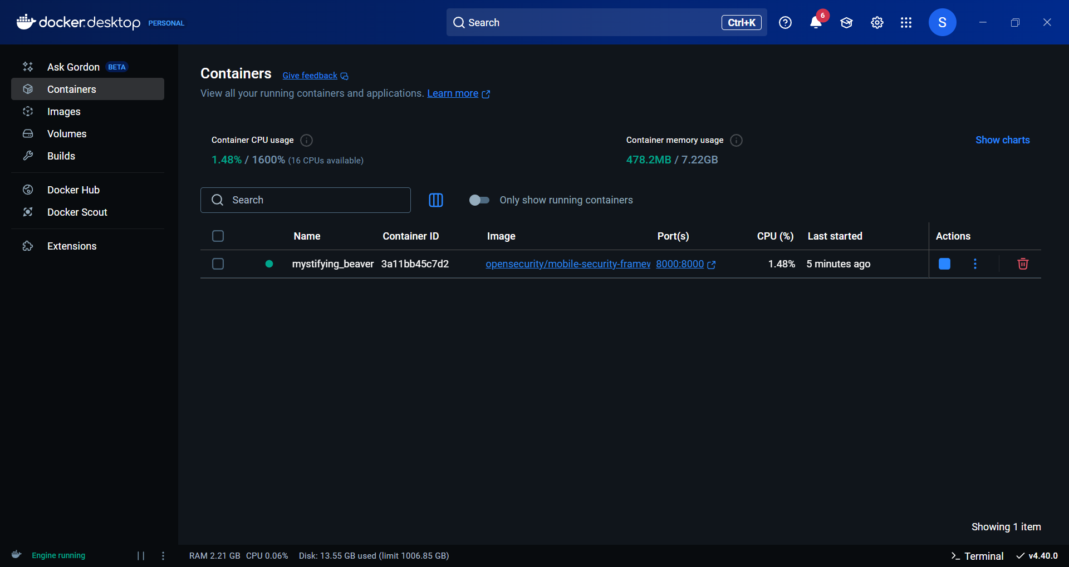

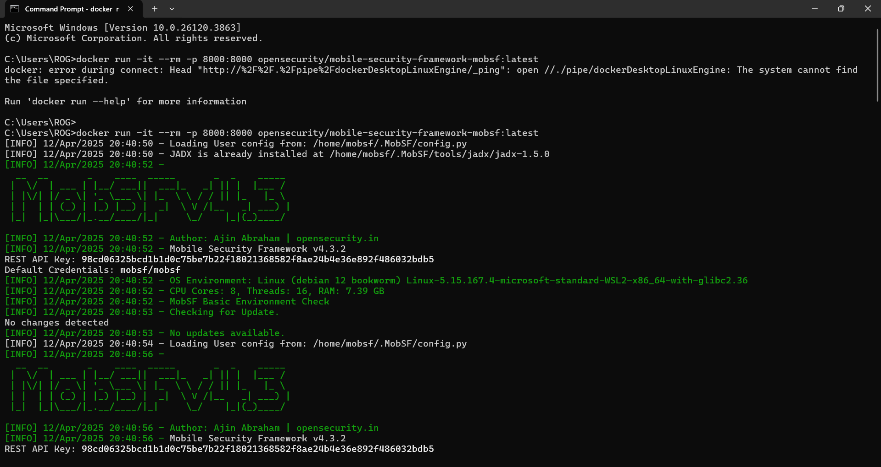

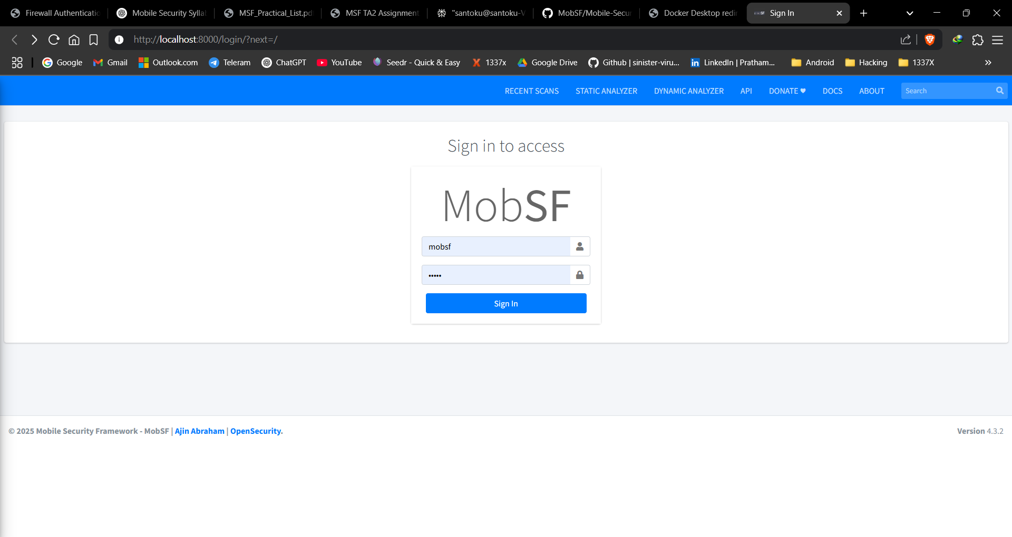

1. **Security Auditing using MobSF (Mobile Security Framework)**

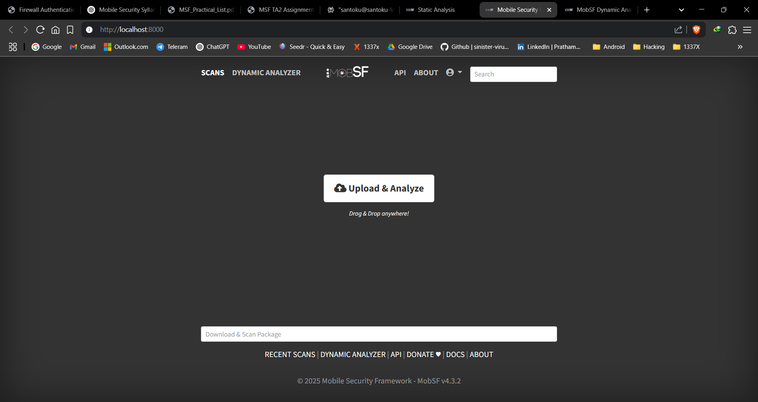

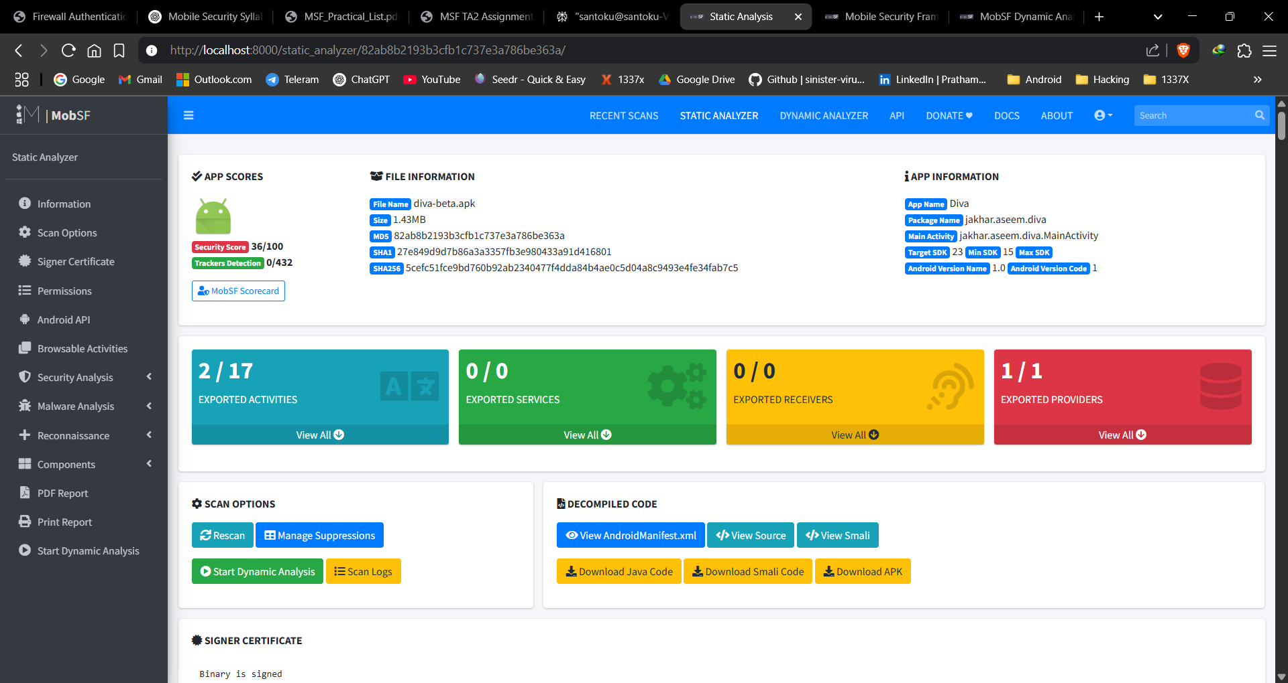

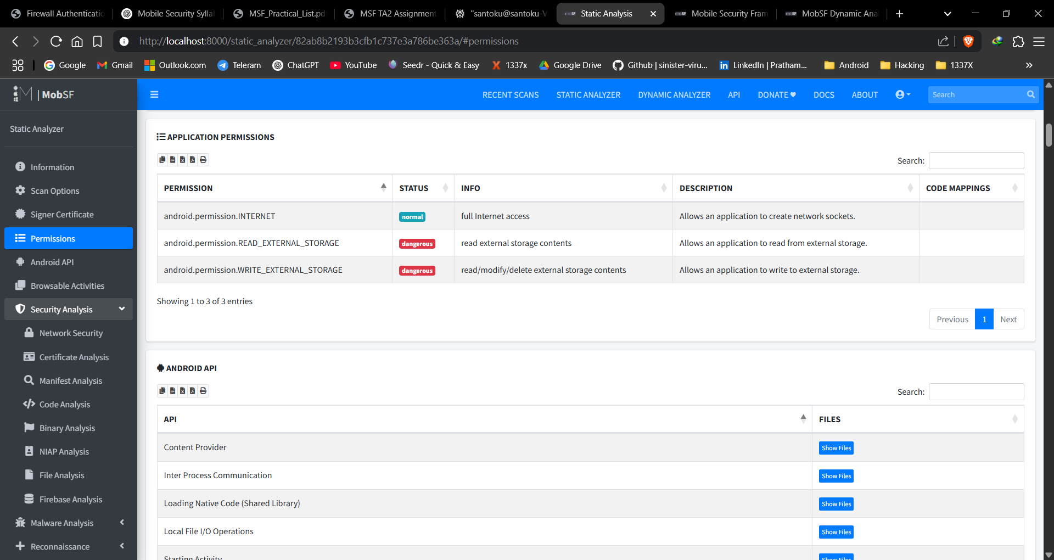

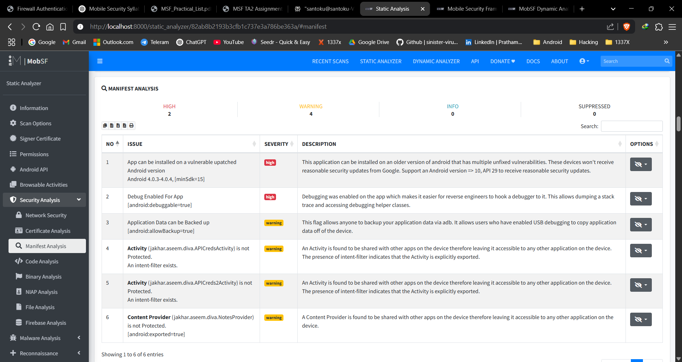

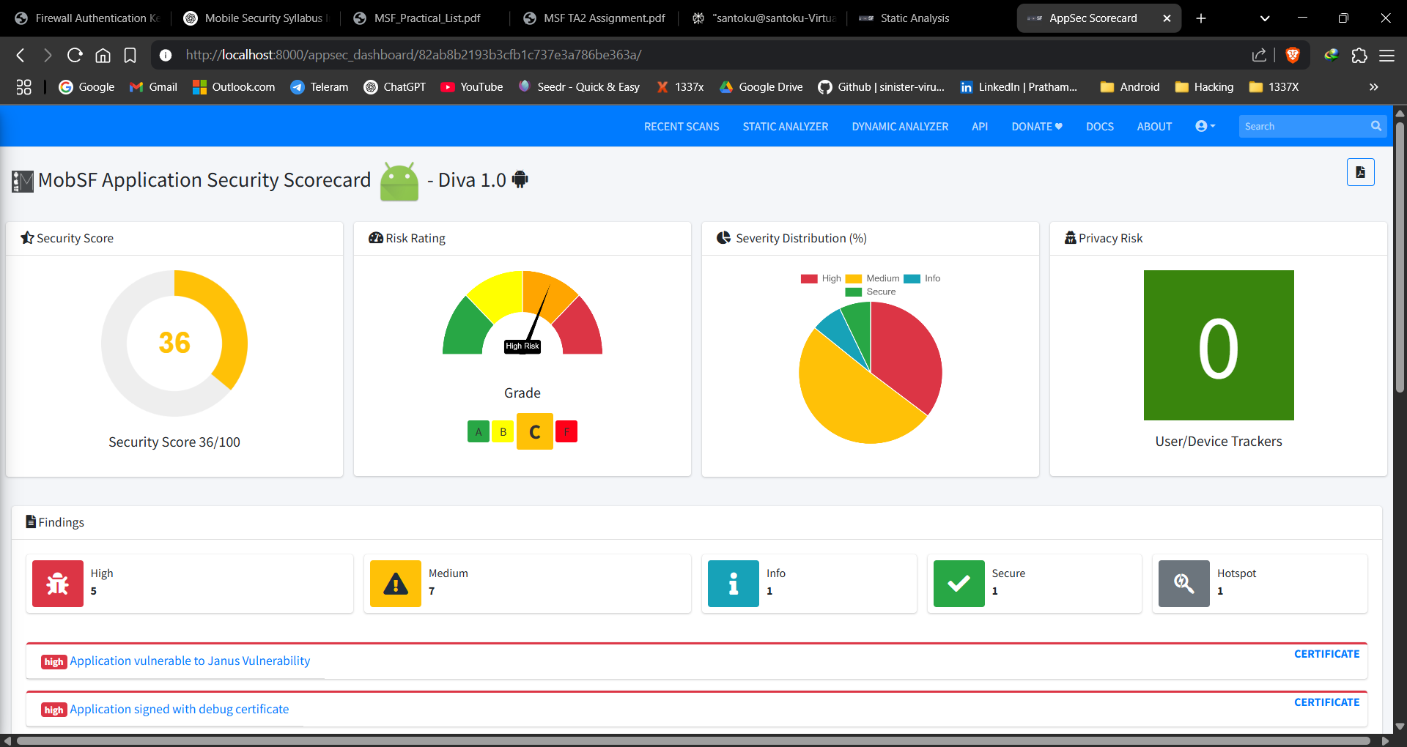

1. **Configuration of Frida**

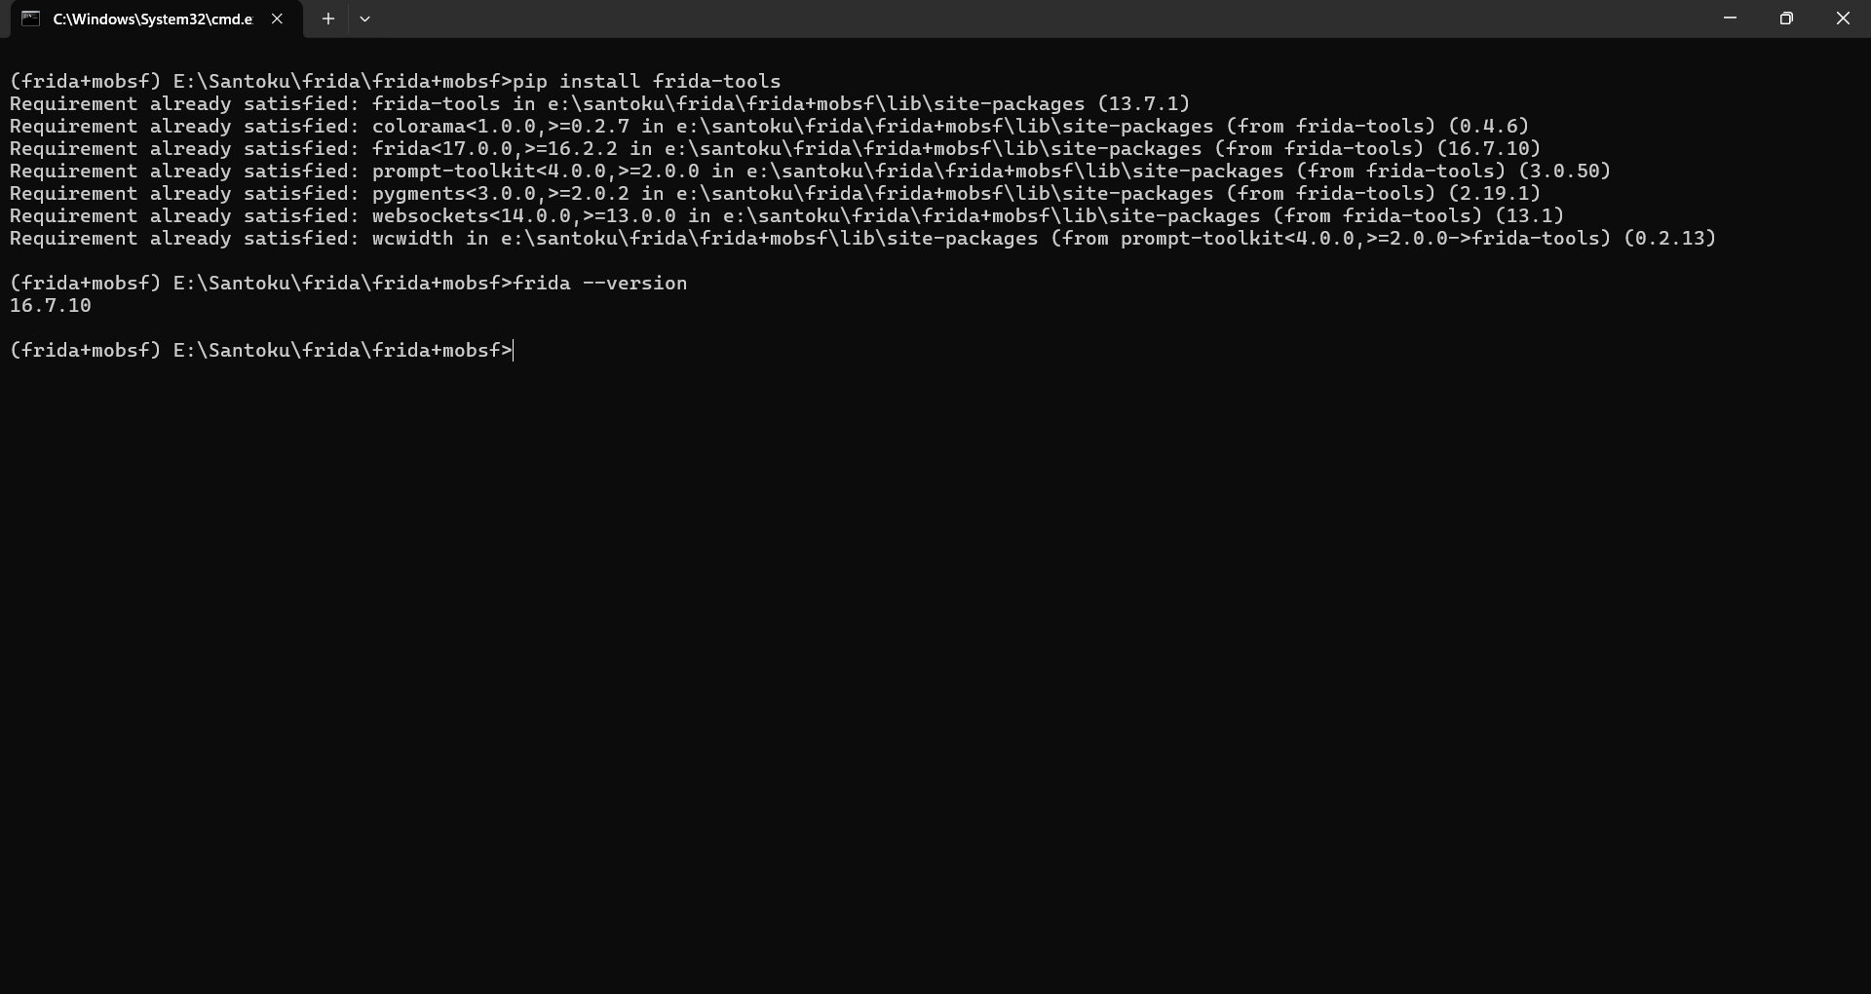

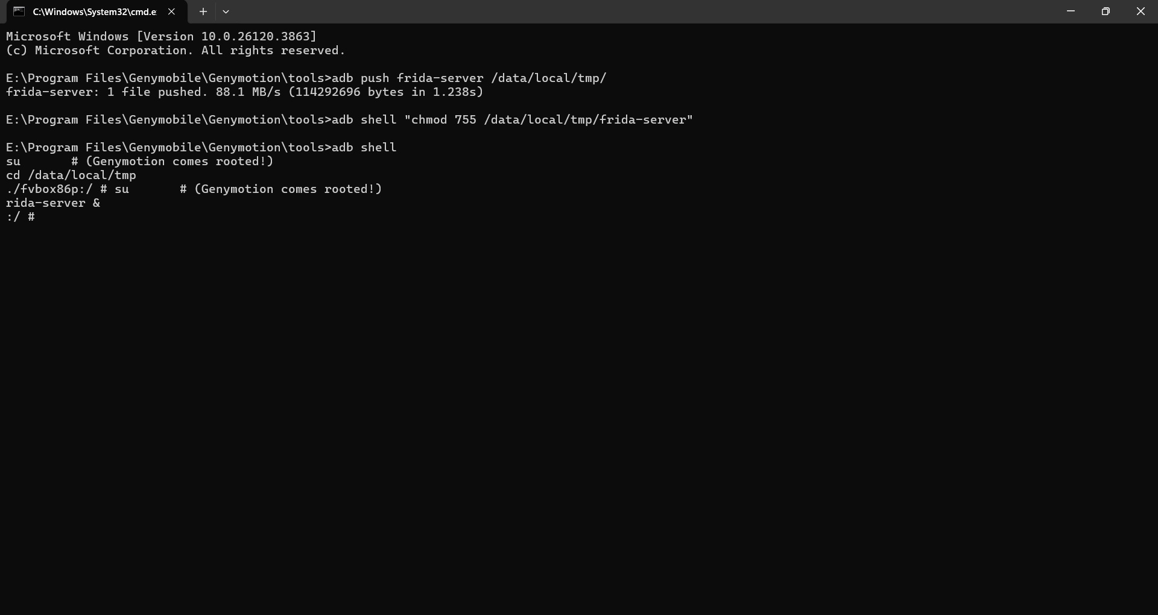

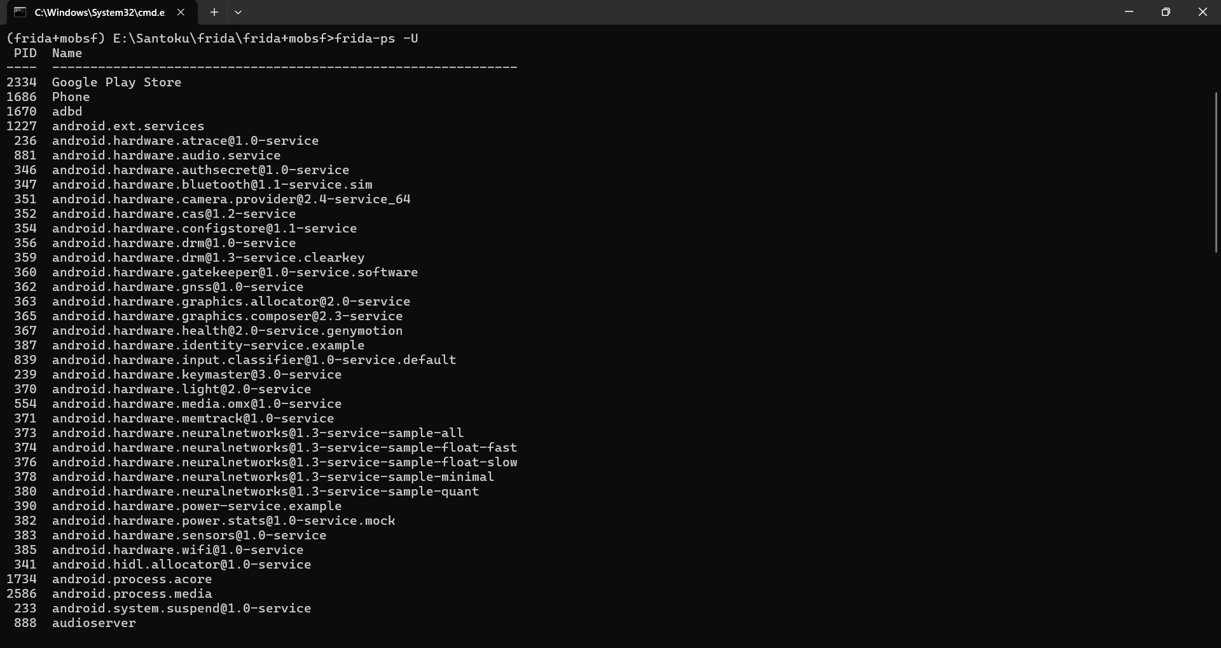

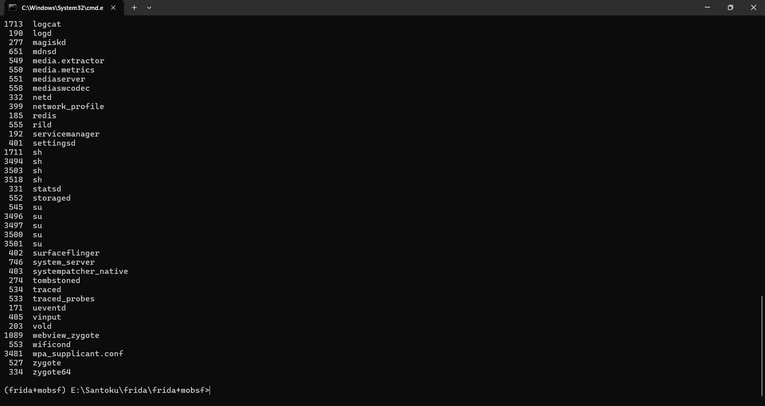

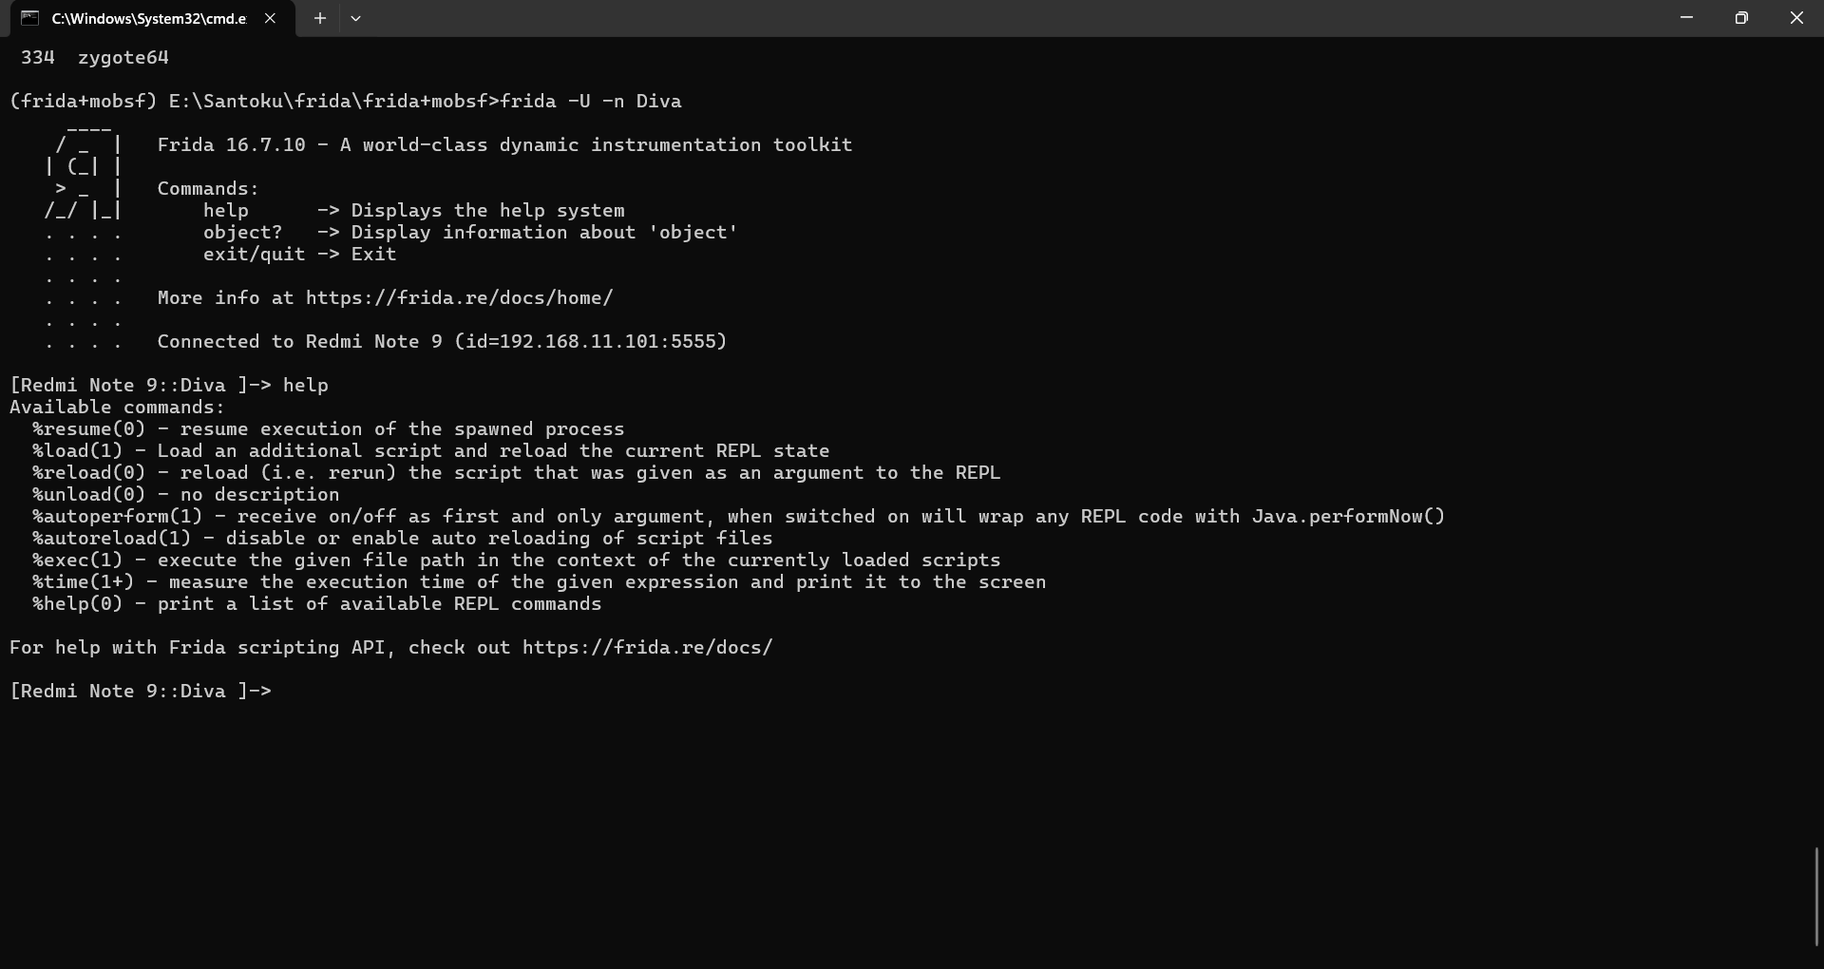

1. **Testing and Evaluation of Android App using Frida**

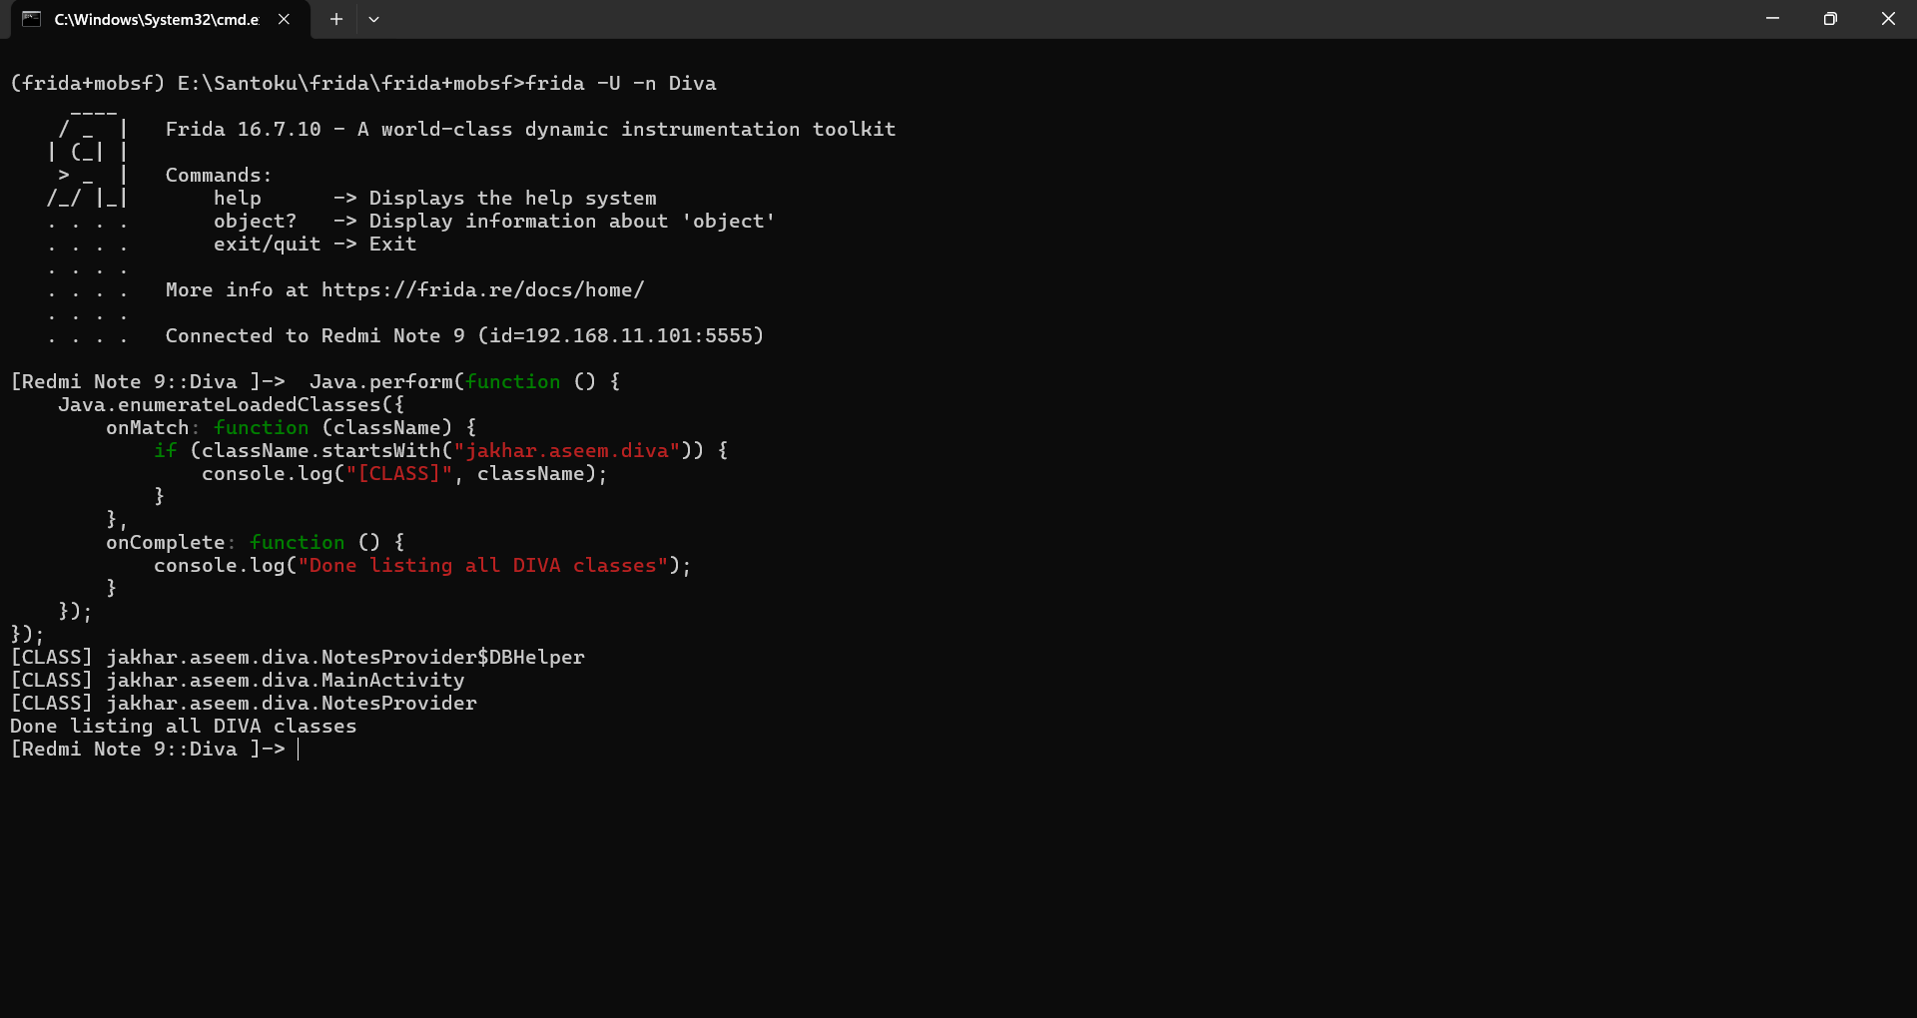

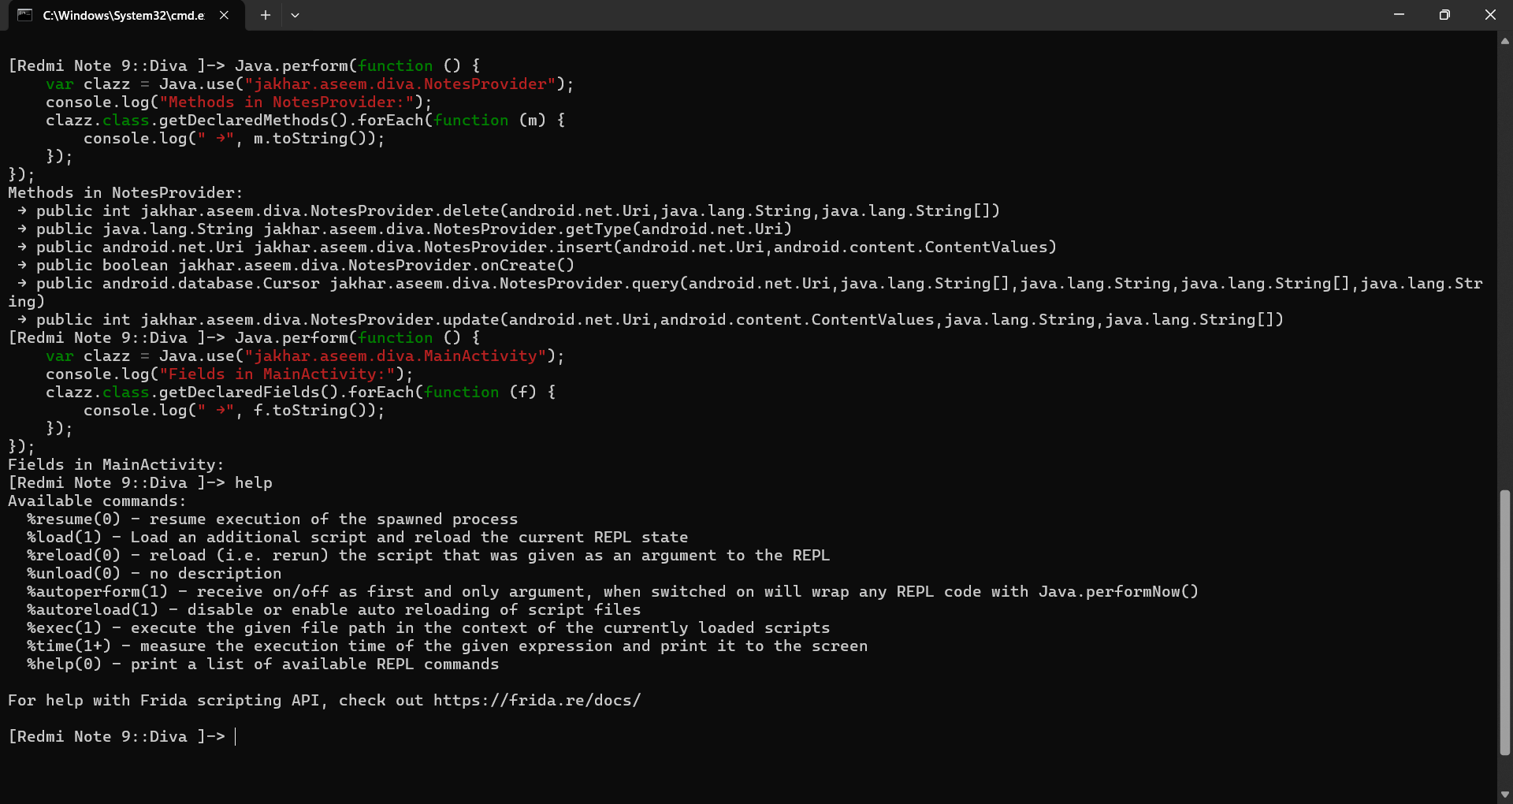

1. **Dynamic Analysis using MobSF and Frida**

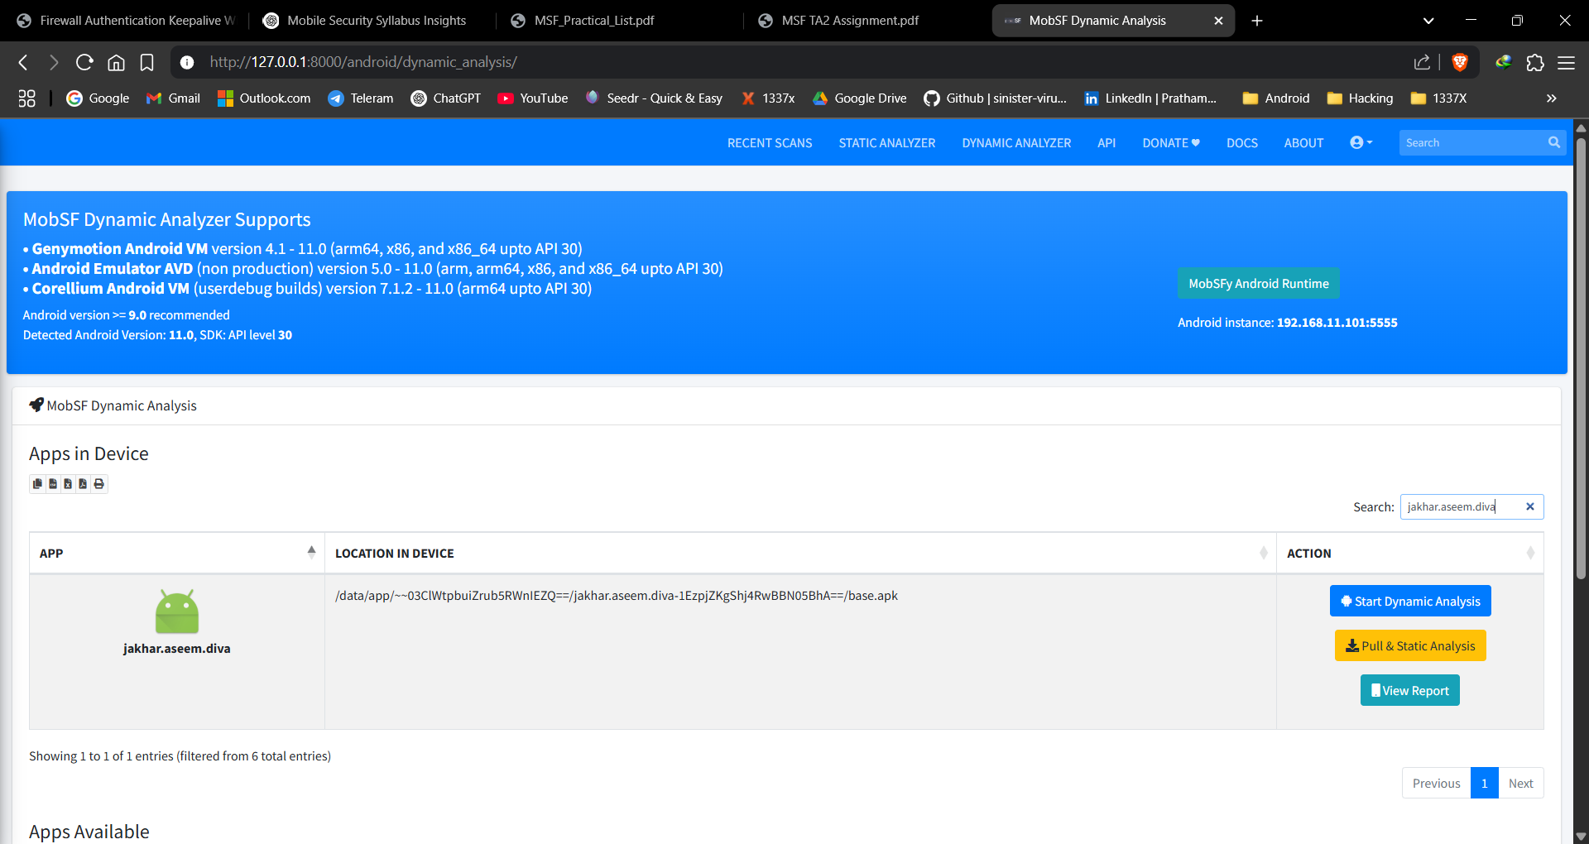

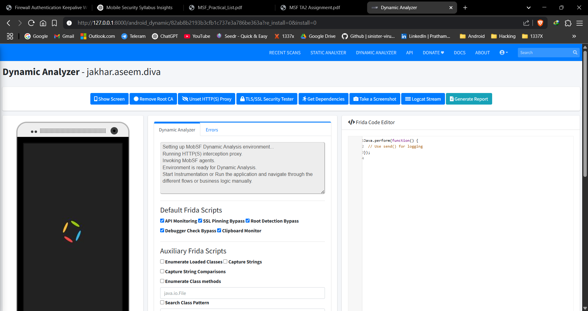

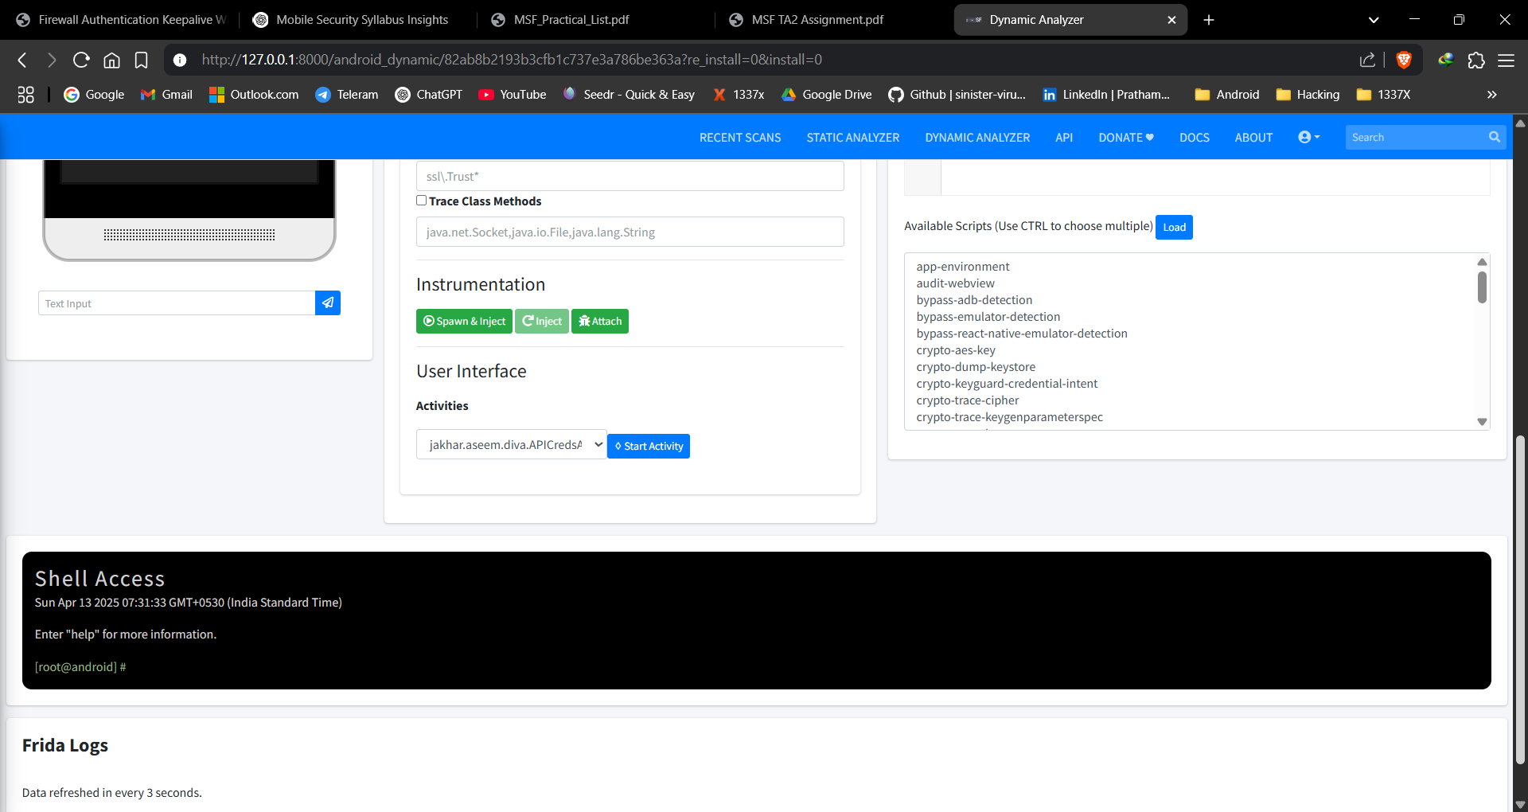

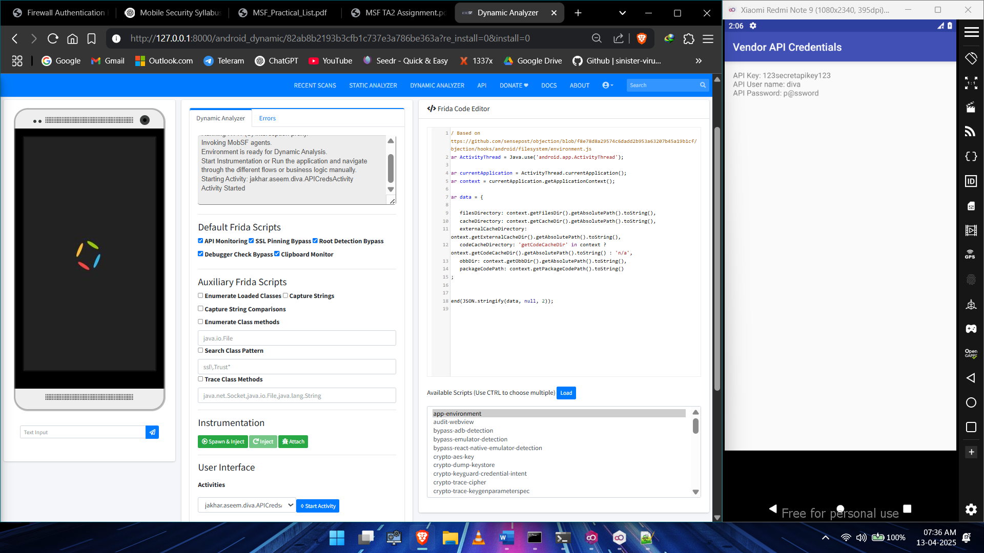

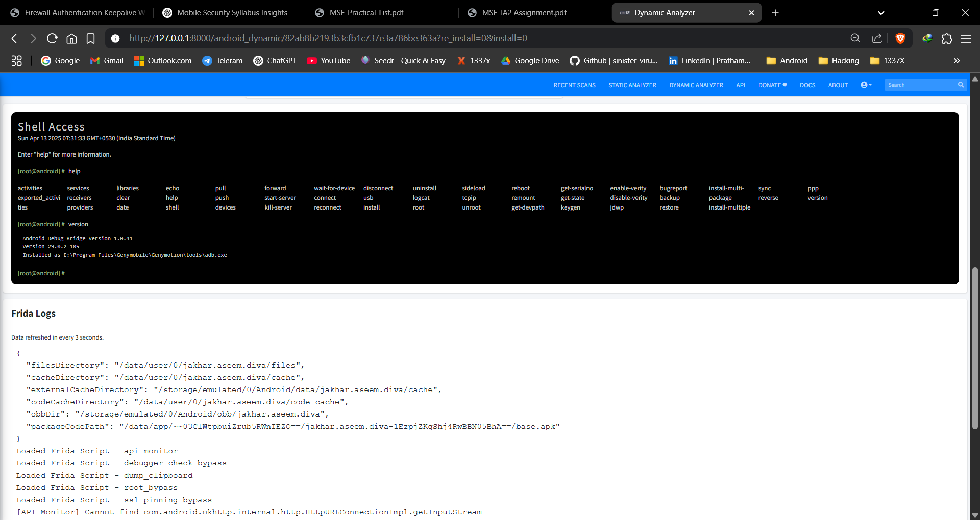

1. **Configuration of OWASP Security Shepherd – Mobile Security platform**
2. **Practical: 01 OWASP Security Shepherd – Mobile Security platform**
3. **Practical: 02 OWASP Security Shepherd – Mobile Security platform**
4. **Practical: 03 OWASP Security Shepherd – Mobile Security platform**
5. **Practical: 04 OWASP Security Shepherd – Mobile Security platform**